Emerging Practice

Title: Building Pathways: Targeted Occupations Business Interview &Tour Project

Submitted by: Nikki Powis
nikki.powis@wintac.org
(907) 957-4702

Source: (please provide specific reference)
- Research Project
- Journal Article
- Other Center
- Information Gathered from VR Programs
- Intensive TA Provision
- Other – connection with American Job Centers (AJCs), Disability Employment Initiative
Highlights:
- A team consisting of WIOA core partners across all four titles came together to identify ways to work together to gain a deeper understanding of employer needs within high-demand occupations.
- The business tours are a way for cross-agency business outreach staff to gain a deeper understanding of the business need, culture and physical work environment to increase responsiveness to both employer and job seekers by making an informed match that is a win-win.

Description:
The information was gathered from members of the SD Disability Employment Initiative project staff. The information that follows is the “How-To” guide developed by the Building Pathways cross-agency team.

Evaluation and Potential Impact:
The practice has enhanced cross-agency relationships and developed an increased network of businesses, thereby increasing employment opportunities for individuals with disabilities.

For More Information, Contact:

Ericka LeVeque, Disability Resource Coordinator, South Dakota Disability Employment Initiative
Ericka.LeVeque@state.sd.us

Gloria Pluimer, Project Coordinator, South Dakota Disability Employment Initiative
gpluimer@clc.tie.net

South Dakota Department of Labor & Regulation
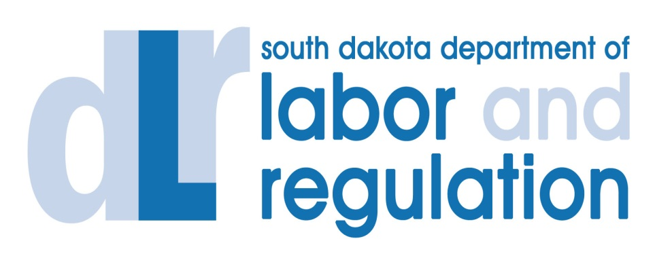

Building Pathways
Career Pathways Element Two:
Identify Industry Sectors & Engage Employers
Targeted Occupations Business Interview & Tour

A project developed by the South Dakota Department of Labor and Regulation
through the South Dakota Disability Employment Initiative (SDDEI).
This Initiative is jointly funded and administered by the U.S. Department of Labor’s Employment and Training Administration (ETA) and the Office of Disability Employment Policy (ODEP).

Building Pathways:
Targeted Occupations Business Interview & Tour Project

A group of individuals from education, training and employment agencies, to include WIOA’s four core partners and other key partners in the Black Hills area, has developed Building Pathways: Targeted Occupations Business Interview & Tour.

The agencies represented include the following:
- South Dakota Department of Labor and Regulation (Title I & III)
- Western Dakota Technical Institute
- Vocational Rehabilitation (Title IV)
- Black Hills Special Services Cooperative/Career Learning Center (Title II)
(Entities and individuals participating in tour may change depending on business to be toured)

The project includes interviewing and touring businesses that are in high need of employees in a particular career field. Once the interview and tour are completed, a small group of staff from these agencies gather to identify customized workforce development strategies that may assist that employer to meet their high demand occupational needs.

The goals of this project are to understand workforce needs as well as the culture of the business and how job seekers’ attitudes, aptitudes and interests align.

Protocol

The goal of Protocol for Targeted Occupations Business Interview & Tour is to put a system in place that allows a strategic method among One Stop partners, to build relationships with and learn from businesses. The customized workforce strategies are services already offered by partner agencies. Organizing these services to meet a business’ needs is great customer service and establishes a formal relationship with the business.

- Targeted occupations identification.
  - Access Labor Market Information Center (LMIC) data for your state/region.
  - Understand the needs in your community in the business arena.
  - Utilize partners in your area that would be most appropriate. South Dakota found these partners to be most beneficial when identifying targeted occupations: Technical institutes, local Society for Human Resource Management chapter (SHRM), regional LMIC, Department of Labor and Regulation Business Services Representatives and technical institute scholarship program. (See Appendix A for Partners.)

- With the partners identified:
  - Develop a list of businesses that have targeted occupations you would like to tour.
  - Establish the frequency of business tours.
  - Identify a lead agency for each business tour.

- Introductory contact to desired host business presenting the concept, partners and inquiry for opportunity. (See Appendix B for example.)
  - Identify a contact point within the business to conduct all communication and follow-up.
- Confirmation email to host business for finalization purposes. (See Appendix C.)
  - Identify date, time and number of individuals attending tour.
  - Advise host business the team will be reconvening to develop customized workforce development concepts based on information gleaned from tour/interview.
  - Interview questions for business tour host. Providing these questions prior to tour/interview may be beneficial for the host to offer well developed answers. (See Appendix D for questionnaire; edit to suit host business.)

- Post-interview/tour email. (See Appendix E for example.)
  - Send summary notes of tour/interview to assure information is accurate and was properly understood.
  - Reiterate team will be developing customized workforce development concepts.

- Post-tour/interview handwritten thank-you notes to host business.
  - Partners provide materials on their services.

- Follow-up/recommendations email. (See Appendix F for example.)
  - Address the identified needs and suggest action items and partners in order to implement customized workforce strategies.

- Customized workforce strategies table attached to follow-up/recommendations email. (See Appendix G for example.)

Career Pathways Element Two:
Identify Industry Sectors & Engage Employers

Targeted Occupations Business Interview & Tour

Appendices

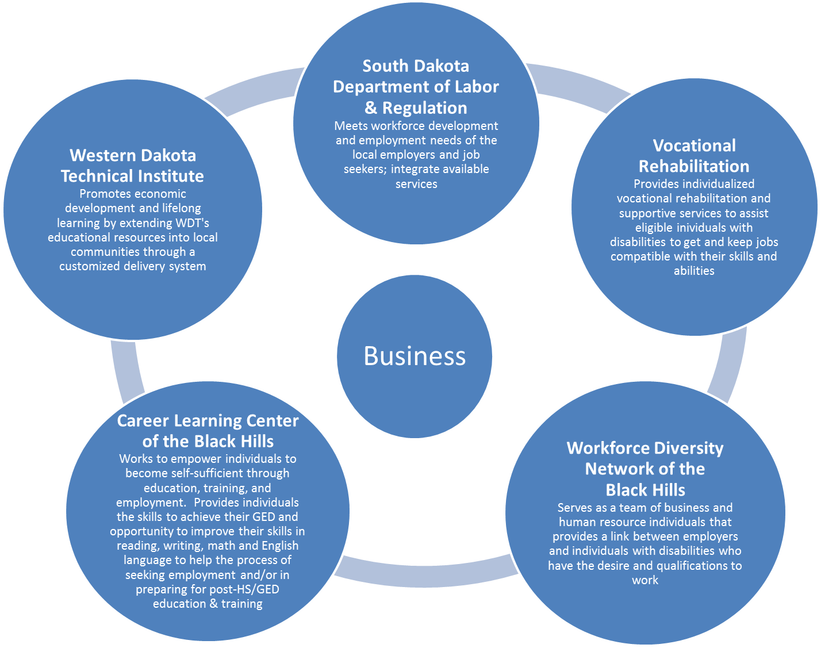
Local Business
Core Partners

Appendix A:
Business Partners

South Dakota Department of Labor and Regulation (SD DLR)
www.sdjobs.org

Vocational Rehabilitation (Voc Rehab)
http://dhs.sd.gov/drs/vocrehab/vr.aspx

Workforce Diversity Network of the Black Hills (Workforce Diversity Network of the BH)
http://www.wdnbh.org/

Career Learning Center of the Black Hills (Career Learning Center of the BH)
http://www.clcbh.org/

Adult Education
http://www.clcbh.org/content/education.htm

Western Dakota Technical Institute (Western Dakota Tech)
http://www.wdt.edu/

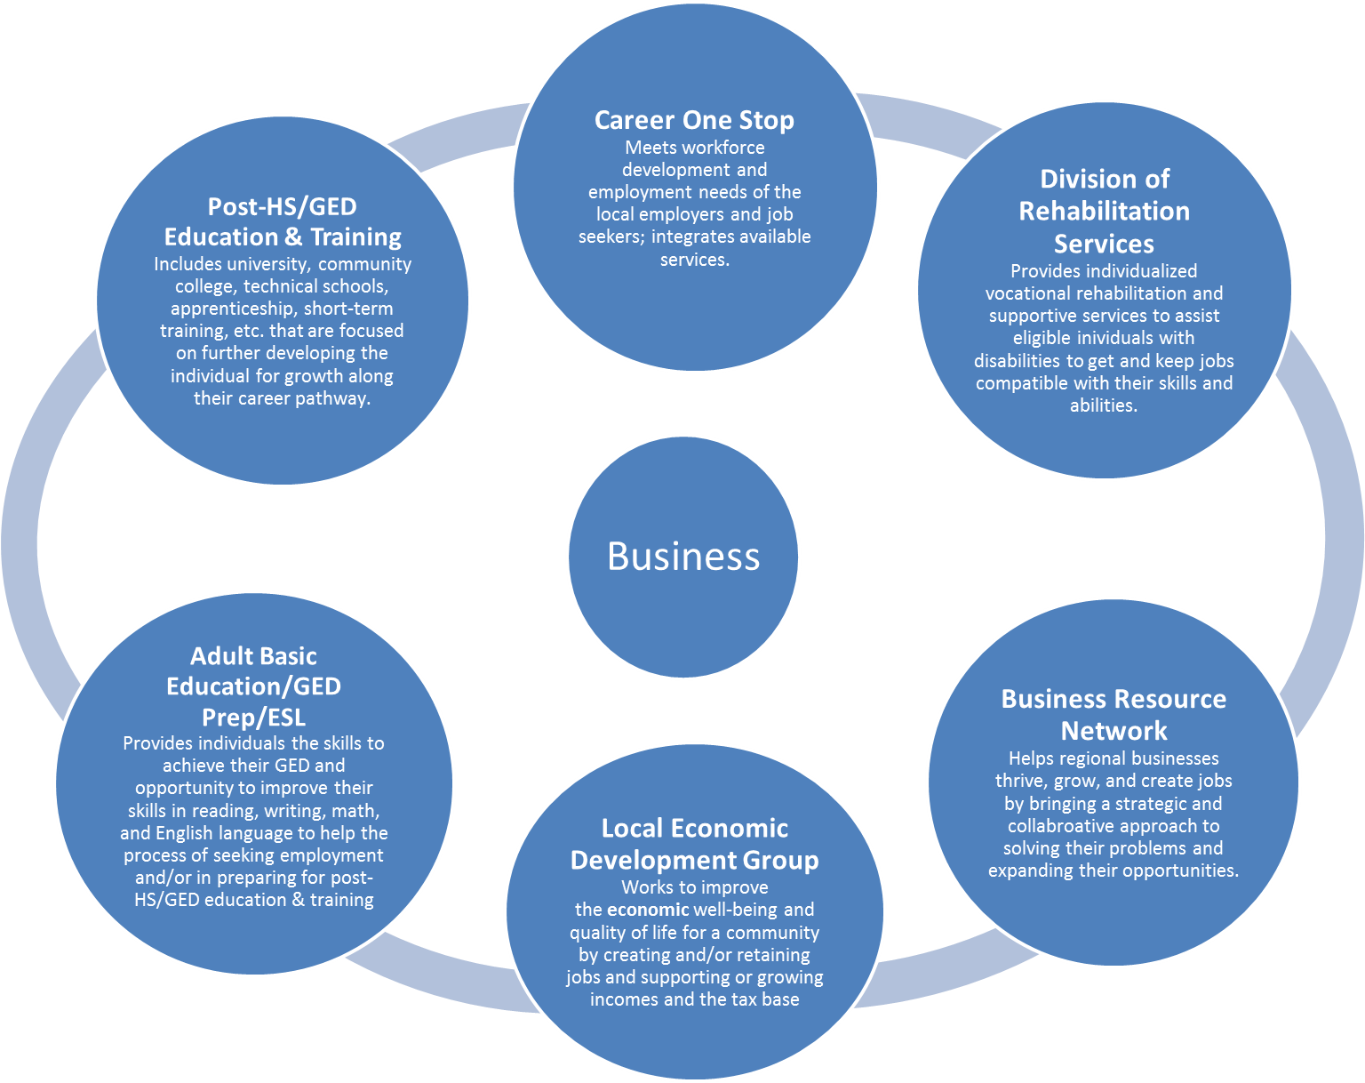
Universal Business
Core Partners

Appendix B: Introductory Email

Good morning, (Primary contact at desired host business).

A group of individuals from education, training and employment agencies in the Black Hills area has developed a Building Pathways: Targeted Occupations Business Interview & Tour project. The agencies represented include South Dakota Department of Labor and Regulation, Western Dakota Technical Institute, Vocational Rehabilitation and Black Hills Special Services Cooperative/Career Learning Center (Entities participating in tour may change depending on business to be toured). The project includes interviewing and touring businesses that are in high need of employees in a particular career field. Once the interview and tour are completed, a small group of staff from these agencies gather to identify customized workforce development strategies that may assist that employer to meet their high demand occupational needs.

Our first business with the project was a car dealership in the Northern Hills who is in need of technicians. We believe the project we have developed will help direct job seekers to their door with the type of attitude, aptitude and interest that aligns with their business culture.

We would like to provide this service to (desired host business). Might we be able to work with you to identify an approach that would provide us with the right information to assist you in meeting your workforce needs? Please advise if this is something in which you have an interest to discuss the best approach for the project with (host business).

I look forward to hearing from you.

(Main Contact and Business Tour Team/Committee)

Appendix C: Confirmation Email

Dear (Primary contact at host business),

Thank you for agreeing to provide a tour and address workforce questions for staff from the South Dakota Department of Labor and Regulation, Vocational Rehabilitation, Western Dakota Technical Institute, and Adult Education. As identified, there will be a group of (# of individuals) meeting at your place of business on (Date) at (Time). (Entities participating in tour may change depending on business to be toured.) Attached is a list of questions we will ask during our tour.

As we discussed, our goal is to identify your workforce needs and develop strategies to assist you in meeting those needs. Each of these agencies provides a variety of products and services to assist and support individuals seeking employment. We have attached summaries highlighting these services and products. (This could be optional). Following the tour, the committee of agency representatives will use information from the interview/tour to develop customized workforce concepts for your review.
Sample

We look forward to learning more about your business and workforce needs. Our purpose is to assist you in reaching your workforce goals.

Sincerely,
(Main Contact and Business Tour Team/Committee)

Appendix D: Questionnaire

High-Demand Occupation(s) Interview Questions
Employer Name ___________________________________
Location__________________________________________
Contact Information_________________________________
Background Information on Company (include website)

Names and Titles of Personnel being interviewed/providing tour

What issues is your business/agency facing in hiring people?

What position(s) is your business/agency having trouble filling?

What are entry level positions? What are the occupations that are a level above entry? What jobs follow those positions? What are the skill requirements to move up?

What type of skills and credentials are needed for the job, and can employees obtain them on the job?

Is your business/agency willing to train or host job shadows/work experiences if the applicant does not have the skills?

Are you comfortable sharing the range of pay (salary or hourly rate) affiliated with each position? What benefits are available to your employees?

Is there increasing compensation along with the increased skill requirements?

Have you ever made an accommodation for an employee? (Examples may include screen reader, ergonomic workstation, speech recognition software for dictating document, phone headset, flex/adjusted schedule.)

Are there any specific workforce needs you have at this time?

Is there anything else you want to share regarding your workforce needs?

Appendix E: Post Interview/Tour Email

Good morning. (Primary contact at host business).

Attached are the notes from our interview with you on (Date). Following the interview, we came together and developed some strategies that we believe might help increase your applicant pool for the high-demand careers you identified.

Please read through the interview notes and let me know of any changes, corrections, additions and/or deletions as we will be developing the strategies founded on the information gleaned.

(Main Contact and Business Tour Team/Committee)

Appendix F: Follow-Up/Recommendations Email

Dear (Primary contact at host business),

First and foremost, thank you for the time you took to showcase your facility. We were all impressed, not only by the superior quality of the facility, but also from the feeling of positive energy that permeates throughout the operation. In discussions following the tour, everyone came away came away impressed with the entire culture and quality and will, no doubt, keep your business in the front and center in their minds as they identify job seekers who might be considered to be a part of your team.

As shared with you at the end of the meeting, a smaller group of people who toured the facility convened to brainstorm workforce development concepts we believe may help increase the number of appropriate candidates for your job positions. We would like to schedule a time for a few members of the committee to meet with you for your feedback of the attached customized workforce concepts.

Thank you for your time,

(Main Contact and Business Tour Team/Committee)

Appendix G: Customized Workforce Strategy Plan for Universal Hospital

Steps to carry out Workforce Development Strategies for Universal Hospital
1. Market job openings and requirements for Patient Care Technicians (PCT) and Environmental Techs.

Action Step | Who Will Follow Up |  | Timeline | Comments
The local Department of Labor and Regulation (DLR) office will list high-demand openings at Universal Hospital on the DLR website, www.sdjobs.org, including PCTs, RNs, and IT positions.  This went into place before our meeting with Laura. | This is completed by DLR Employment Specialists who met with Chief HR Office for Universal Hospital, Inc. on November 6, 2015. | Done
DLR Employment Specialists will visit with DLR Assistant Manager about setting up a presentation with PHR on Universal’s workforce needs for DLR staff and partners (i.e. VR, CLC). | DLR Employment Specialists |  | They will visit with DLR Assistant Manager by the first week of December and schedule a date/time for presentation. | DLR Employment Specialist will visit about having Universal HR staff input job openings on the DLR website as they come up.  For the presentation, ask PHR to emphasize educational requirements; on the job training opportunities; wage per hour; and internal promotion opportunities.  Also—find out if they have an employee referral program.
VR Counselor and Director of WDN will schedule a presentation with PHR to the VR Providers’ group. | VR Counselor | VR Counselor will visit with Director of VR about scheduling this presentation and contact PHR on a date/time to present.
DLR Employment Specialist will follow up with PHR on the NCRC information she sent for consideration of an employee getting their NCRC at a level identified for a PCT, being hired, with the understanding of GED completion in an appropriate timeframe. | DLR Employment Specialist |  | Mid-December | DLR Employment Specialist will wait to hear from PHR and if she has not by mid-December, she will contact her again.
Tech Institute/Community College Associate Dean of Advancement will visit with PHR more about the hybrid CNA program to see if this is training that we can partner on to fill this need. | Tech Institute/Community College Associate Dean of Advancement | Tech Institute/Community College Associate Dean of Advancement will contact PHR to visit specifically about this Training by mid-December.

2. Market educational opportunities in the RC area for Registered Nurses and beyond.

Action Step | Who Will Follow Up | Timeline |  |  | Comments
The DEI staff will develop a career pathway illustration on how to earn a RN and beyond in the Rapid City area beginning with a high school diploma or GED. This will feature all of the credential earning areas leading to an RN and beyond. It will be a simple illustration so students of all ages can follow it. It will include where one can go in SD and specifically the Hills area to earn these credentials. | CLC Services Coordinator | January 2016 |  |  | Develop a draft and then run it by PHR for input from her team. The illustration could be used at all levels & within all agencies and organization (i.e. middle school, high school, CLC-Adult Ed, DLR, VR, Tech Institute/Community College).  Add information on suggested classes to take in high school.  Use SD DOH’s Health Occupations for Today and Tomorrow (HOTT) website as a resource.
Tech Institute/Community College Associate Dean of Advancement will work with Laura on specific needs and opportunities for LPN graduates and will work with LPN graduates as needed. In addition, Tech Institute/Community College Associate Dean of Advancement will make sure Universal is invited to the spring Career Fair at Tech Institute/Community College on Feb. 10. | Tech Institute/Community College Associate Dean of Advancement |  | Tech Institute/Community College Associate Dean of Advancement will visit with PHR about this by mid-December, and create a plan for spring.

3. Research possibilities of offering a Respiratory Therapist Program at Tech Institute/Community College.

Action Step | Who Will Follow Up | Timeline | Comments
Tech Institute/ Community College Associate Dean of Advancement will visit with Tech Institute/Community College administration about the possibility of an A.A.S. in Respiratory Therapy. | Tech Institute/Community College Associate Dean of Advancement | Early December | The process to start a new program typically takes up to two years, but as a first step, Tech Institute/Community College Associate Dean of Advancement will see if this has been explored before/if it is something Tech Institute/Community College is interested in.

Department of Labor and Regulation
Vocational Rehabilitation
Career Learning Center
Workforce Diversity Network (A team of business and human resource individuals that serve as a link between employers and individuals with disabilities who have the desire and qualifications to work)
Disability Employment Initiative

