Emerging Practice

Title: Coordinating youth services with multiple partners in Alaska

Submitted by: Nikki Powis
nikki.powis@wintac.org
(907) 957-4702

Source: (please provide specific reference)
- Research Project
- Journal Article
- Other Center
- Information Gathered from VR Programs
- Intensive TA Provision
- Other – connection with Department of Education, American Job Center, Disability Employment Initiative, Community Rehab Providers, Career Pathways providers, business and industry.
Highlights:
- Alaska VR has taken the leadership role in development of youth transition services and engagement of youth with disabilities into existing career pathways programs. Partnerships are with K-12 Education, AJCs, DEI project, Community Rahab Providers, Independent Living Centers, Mental Health Trust, Regional Training Centers, University System and industry sectors.
- These initiatives leverage funding across multiple partners, staff time and resources, allowing for shared outcomes and for efficient and effective service delivery.
- Recent data from K-12 education have demonstrated the VR-led initiatives have already positively impacted graduation rates, resulted in a higher proportion of youth with disabilities entering career pathways programs, and greatly increased exposure to employment and career options, and increased industry partnerships.
Description:
This description was generated from information gained through involvement with Alaska through the DEI and WINTAC technical assistance services, interviews with VR and workforce staff and literature and reports:
Alaska Division of Rehabilitation (DVR) is responding to the requirements under the Workforce Innovation and Opportunity Act (WIOA) to partner with education, human services and workforce. In addition, DVR is responding to the requirement to develop an inclusive career pathways system.
To accomplish this, DVR has established partnerships with the Alaska Mental Health Trust, the Department of Labor and Workforce Development’s Disability Employment Initiative, the Department of Education and Early Development, the Division of Juvenile Justice, Community Rehab providers and business and industry and has instituted a variety of projects. These projects, combined with DVR counselors’ efforts at the local level, provide the foundation to reach over 600 youth with disabilities per fiscal year, opening opportunities for the future to self-sustaining careers.
Details directly from DVR on these initiatives are below:
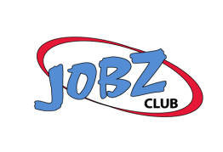
JOBZ Club: JOBZ Clubs occur after school and use engaging activities to introduce students to “work readiness skills.” Last year, over 45 students participated in eight different JOBZ Clubs across the state. DVR pays teachers to facilitate clubs in their schools. We anticipate reaching over 100 predominately rural youth through JOBZ Club activities this school year. JOBZ Club is a great vehicle for teachers to prepare students for transition and also helps the teacher better connect with DVR.
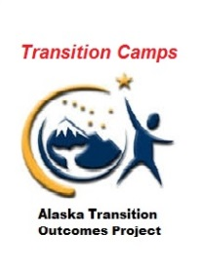
Transition Camps: DVR partners with the Department of Education and Early Development (DEED) and DEI to fund Transition Camps, contracting with a team of highly qualified special education professionals through Southeast Regional Resource Center. The Transition Camp team travels across the state. Each camp consists of a rigorous three- to five-day experience for youth that broadens their knowledge and perspective through exposure to area businesses, industries, post-secondary education, training and apprenticeship options that open horizons and possibilities. Camps are held within local school districts and the state’s Juvenile Justice facilities to ensure the experience is open to all youth. Last year, over 100 students participated. The goal is to reach over 200 students this year.
Engagement of Business and Industry through Transition Camps: Last year, over 60 Alaskan businesses participated in the Transition Camps. This involvement has had a significant impact on the youth, as demonstrated through student feedback surveys. Interaction with business and industry representatives who have shared their own personal career journey has been most impactful. Giving the gift of insight into the career decision-making process and learning how someone who may have started where they are has successfully navigated barriers and opportunities has been inspirational for many of the youth.

Businesses participate in one or more Transition Camp throughout the year, and DVR is always looking for additional business presenters and mentors for the youth. Wells Fargo and the Alaska Process Industry Careers Consortium have become an integral part of the camps, demonstrating a strong commitment from business, and AVTEC and the University of Alaska have provided the vision and pathway to postsecondary education.
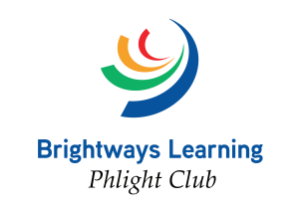
Phlight Clubs: DVR contracts with Brightways Learning to conduct Phlight Clubs in school districts across the state. Phlight Clubs are three-day, lock-in events designed to engage youth and their families for cultivating caring and connected schools and communities. Phlight Club incorporates Pre-ETS self-advocacy and work readiness skills training activities to help youth develop self-esteem and leadership skills. This is a new project and we anticipate engaging over 50 students with disabilities in Phlight Clubs this school year.

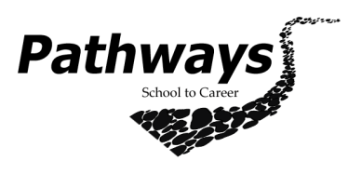
PATHWAYS School to Career: DVR Partners with Northwestern Alaska Career and Technical Center, EXCEL AK and Voyage to Excellence Career and Technical Education program to offer an intensive array of courses that combine Pre-ETS activities with “hands on learning” in specific career fields such as culinary, carpentry and welding. DVR funding increases the effectiveness of the courses by increasing the staff-to-student ratio and needed disability supports. These courses offer exposure to the stepping stone credentials students need to be competitive candidates for postsecondary education and training towards apprenticeships. So far this state fiscal year, 29 students have participated in Pathways activities.
Pre-ETS Projects: DVR contracts with nine agencies in rural and urban areas to provide an intensive array of Pre-ETS activities. Each youth receives instruction in job exploration and work readiness training with 40 hours of paid work experience to practice those skills. Last year, over 150 youth participated in Pre-ETS Projects run by behavioral health, developmental disability and independent living organizations.
Summer Work programs: DVR, in partnership with the workforce system’s Disability Employment Initiative, is in process of awarding contracts to 10 Community Rehabilitation Program (CRP) providers throughout the state to provide summer work experience to students with disabilities. The summer work experience program is our biggest effort to engage students in Pre-ETS activities with the opportunity to have a six-week paid employment opportunity this summer. The project is designed to fund programs statewide to serve 200 students. The project was creatively designed to allow students of any ability to participate in programming that leads to competitive integrated employment.
Evaluation and Potential Impact:
As a result of the partnerships around the youth initiatives, deeper cross-agency relationships have been developed, and other services are seeing the benefit. DVR and the workforce system have identified a common intake and data sharing for youth in these programs that can be replicated for other populations.
As mentioned previously, graduation rates have been positively impacted by the increased engagement with youth. Youth have a greater exposure to career options and employers are more engaged and a partner in the process of educating youth for a higher skilled future workforce.
For More Information, Contact:
Jim Kreatschman
(907) 465-6931
Jim.kreastschman@alaska.gov

