Quick Reference Card: Viability
The Viability tab contains labor market information about wages, job trends, and industries. This information can be used to determine if an occupation is economically viable where you want to live and work.
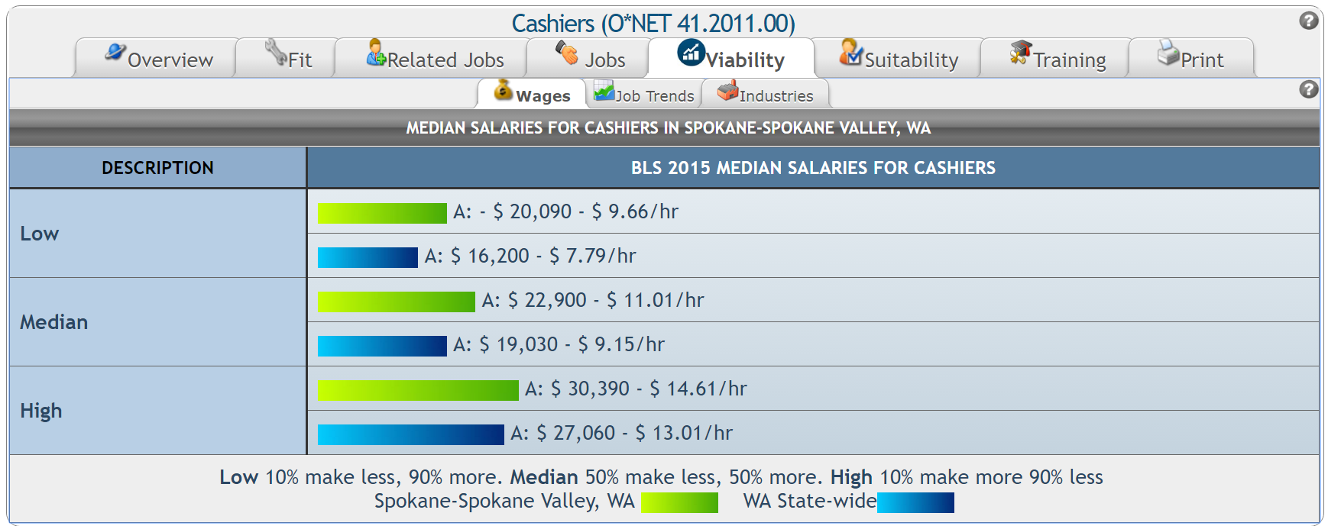
The Wages sub-tab contains salary information for the selected occupation. To help determine if an occupation is economically viable, compare the Wages information with your desired salary range.
The bar graph at the top of the Wages sub-tab provides Occupational Employment Statistics (OES) data from the U.S. Department of Labor’s Bureau of Labor Statistics (BLS). Median salary data are based on an annual survey that asks what the respondents earned during the three-year period prior to the survey. Salary data are separated into three categories: low (10% earn less, 90% earn more), median (50% earn less, 50% earn more), and high (90% earn less, 10% earn more).
The first bar in each section (which appears green) represents local data, while the second bar in each section (which appears blue) represents state-level data. Next to each bar, the letter A represents the annual salary. Hourly rates are provided next to the annual salary.

The Job Trends sub-tab provides local, state, and national labor market trends from the U.S. Department of Labor and State Labor Market Information (LMI) divisions.
State projections include the State Job Outlook, the 10-year projected annual growth, number of job postings that need to be filled within the 10-year period, total workers in the occupation, and annual job openings. Local data for the specified area include the number of total workers in the area, the number of workers in the selected occupation, and the number of current job postings.
National projections data include the 10-year projected national growth, the National Job Outlook, and the area with the highest concentration of workers in the selected occupation. (Date ranges for the 10-year projections may vary.)
Where rankings are provided, the figure is compared to all other occupations in the area. For example, “Ranks top 9% in state” next to Annual Growth means that the occupation is growing annually more than 81% of all other occupations in the state. National and State Job Posting Volume graphs from Indeed® are included at the bottom of the screen. These depict the change, over time, in the number of job postings for the selected occupation.
The Industries sub-tab lists the top industries (in order) for the selected occupation, along with a link to potential, local employers, the percent of workers in the occupation who work in the industry, the number of workers in the industry nationally, and the projected 10-year growth for the industry.
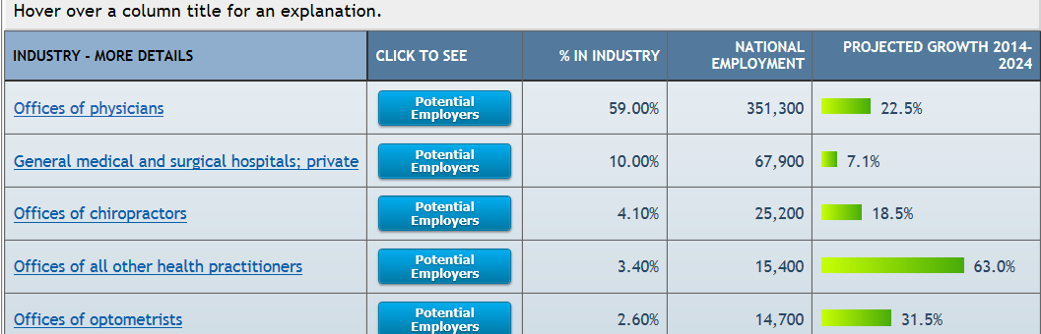
Clicking the industry name provides a list of the top 15 jobs in the industry. The 15 job titles are compiled in a table (example, below) with the average wage range, number of people employed in the job in the chosen area, the percent of people employed in that particular job compared to the industry as a whole, and the projected growth between 2014-2024.
Clicking on a particular job title will take you back to the occupation information page.
