Quick Reference Card: Training

Training
The Training tab contains information about Schools, Licenses and Certifications, Related Training, and Experience/Education related to the selected occupation.

Schools
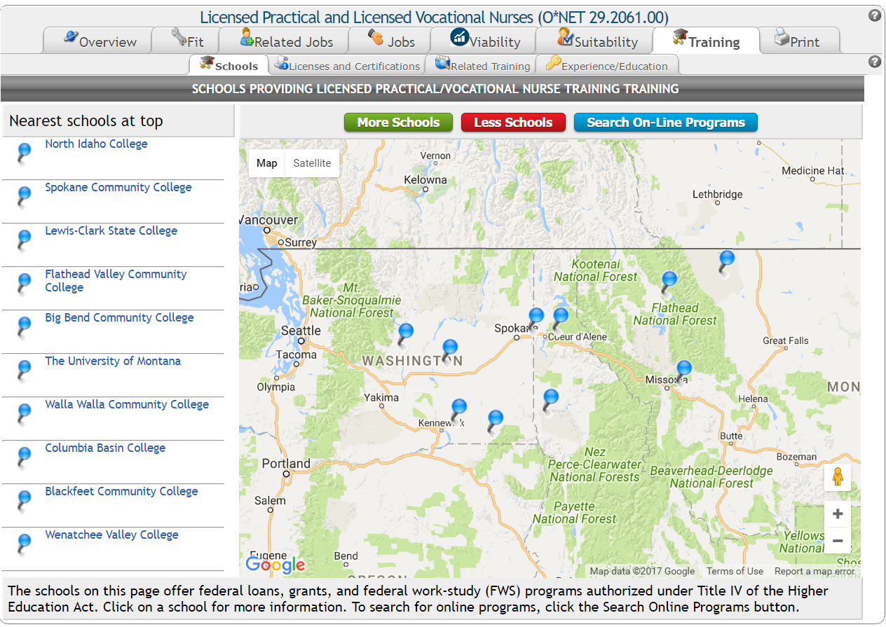
The Schools sub-tab contains a list and interactive Google Map of schools that provide training for the selected occupation. This information is provided by the Department of Education and only includes schools that a) provide student loans and grants and b) are located within 40 miles of the specified location.
If no schools are found within 40 miles, the 10 closest schools are displayed.
Clicking More Schools expands the search area.
Clicking Less Schools reduces the search area.
Clicking Search On-Line Programs will open a window displaying potential on-line programs for the selected job title.
The Career Index Plus contains detailed information on more than 200,000 training programs.
Clicking on a school name pinpoints the location on the map and displays links to detailed school information.
- The Program Info link contains information about the school’s related training programs. From there, clicking the Research This Program link opens a Google Search on the program for that school.
- The School Info link provides detailed school information from the Institute of Education Sciences (IES), National Center for Education Statistics (NCES), College Navigator site.
- The Street View link shows the Google Map Street View.
- The website link below the address and telephone number opens the school’s website in a new tab or browser window.

Licenses and Certifications
The Licenses and Certifications sub-tab contains information about state licenses (first) and national certifications (next) related to the occupation.
The screen will alert you if no licenses and/or certifications have been identified for the selected occupation or state. License/certification information includes the type (core or specialty), name, licensing/certification authority and website, and a link (URL) to related job openings. Clicking the license/certification name provides additional information about the license or certification.

Related Training
The Related Training sub-tab contains the Title and Description (with examples) of training programs related to the selected occupation. Clicking on a title provides additional information about the related O*NET Job Family.

Experience/Education
The Experience/Education sub-tab contains information about the amount of experience and education typically required for the occupation. This screen displays up to six categories of education and experience that employers are looking for in potential candidates for the selected occupation. These categories are described below.
The Preparation Level information is based on O*NET Job Zones. A Job Zone is a group of occupations that are similar in how much education, related experience, and on-the-job training people need to do the work. There are five Job Zones. The higher the Job Zone, the more preparation is needed (see table below).
Table 1: Job Zones
Job Zone | Amount of Preparation Needed
1 | Little or none
2 | Some
3 | Medium
4 | Considerable
5 | Extensive
The Typical Qualifications information is based on employer job ads.
The Most Common Related Work Experience section includes Bureau of Labor Statistics (BLS) employer survey results regarding the amount of related work experience employers look for when hiring for the selected occupation.
The Typical Required Education Level section includes BLS employer survey results regarding the typical education level employers look for when hiring for the selected occupation.
The Most Common On-The-Job Training section includes BLS employer survey results regarding the amount of on-the-job training (if available) that can be expected for the selected occupation.
The Most Common On-Site or In-plant Training section includes BLS employer survey results regarding the amount of on-site or in-plant training (if available) that can be expected for the selected occupation.
Under each category, various levels of experience, education, or training are listed. The percentages next to each level represent the number of survey respondents within the occupation with that level of experience, education, or training. The levels with the highest percentages represent the most common experience, education, or training level at the time of the survey.

