TCI+ and the IPE
The Career Index Plus (TCI+) is a career information system that collects Labor Market Information (LMI) from a host of resources and deposits it onto a single, user-friendly site. This document will discuss how to use the data within TCI+ to provide a VR client with an informed choice in relation to her strengths, priorities, concerns, abilities, capabilities, and interests, ultimately documenting the data found in the Individualized Plan for Employment (IPE).

Client Information Needed to Begin
For TCI+ to be used as an Informed Choice tool, the VR professional will need to begin by obtaining information about the client, such as past education, degrees, and credentialing obtained, work history and vocational experience, and work preferences. Once these and other items are obtained, you may use TCI+ to compare the client specific information with the correlating occupation-related data presented here.
What is a description of the vocational goal?
Within the Overview tab, every job has a simple written description and most have a short video description. Does this sound like the job the client is interested in?
What are the clients desired earnings?
The Overview tab also has comparable data. However, the Viability tab – Wages subtab provides a more in-depth analysis for entry, median, and highly paid employees. Will these wages meet the client’s economic needs?
What type of education/experience does the client have?
The Overview tab again has this data. Yet, the Training tab – Experience / Education subtab has a more in-depth analysis. Does the client have the training and or experience to enter this field?
Does the client want full-time or part-time work? What shift?
The Overview tab has this data. While every specific job will be different, it is possible for the client to review the most commonly expected hours and shift information.
What type of strengths, abilities, knowledge, and skills does the client possess?
The Suitability tab is filled with data that will assist in showing this is a good match for the client. Please proceed through the rest of this guide to find out more.

Strengths, Resources, and Priorities
There are many areas within TCI+ that offer important data in relation to a client’s strengths, resources, and priorities.
Strengths are typically defined as either activities that you can do well or as qualities that assist in completing those activities. For example, if I am an empathetic person (quality), I may be good at giving advice (activity). Within TCI+, Strengths may be identified throughout the Suitability tab. We recommend looking within the Tasks and Activities subtabs for activity-based strengths, and within the Styles and Values subtabs for quality-based strengths.
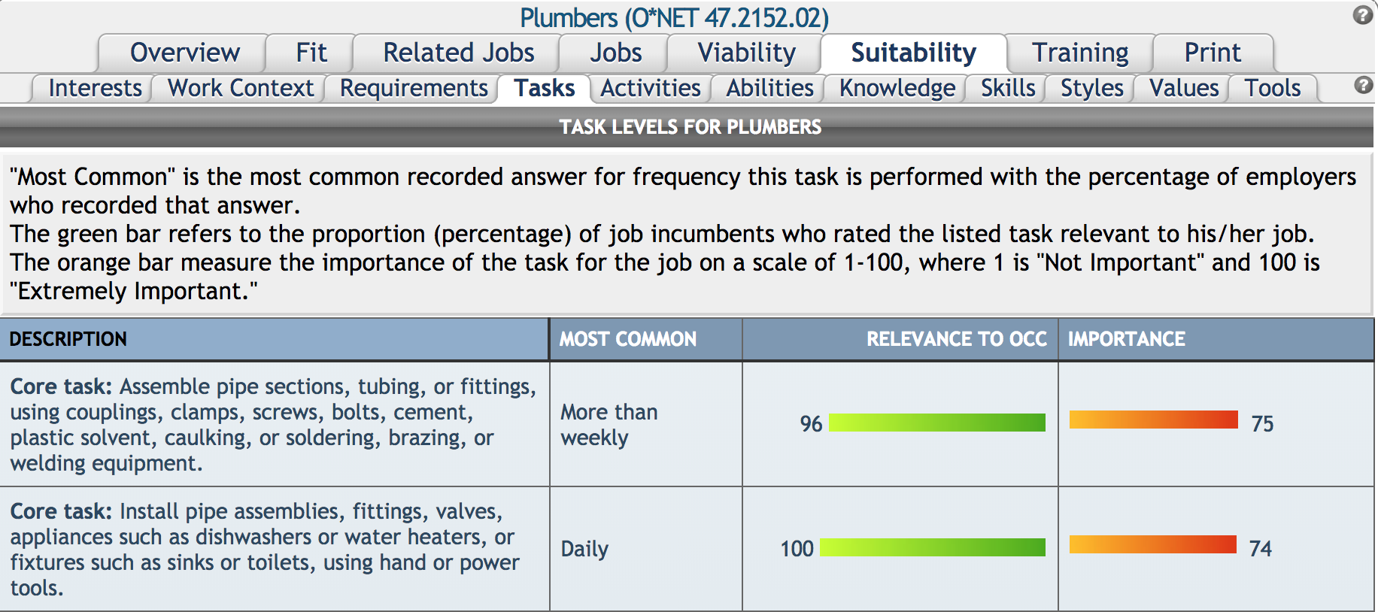 | 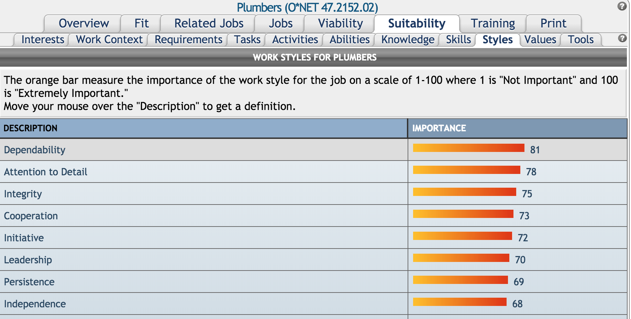
Resources, on the other hand, are typically defined as assets available to realize a goal. For example, social security payments, natural supports, community supports, insurance, and other items would be considered Resources. Within TCI+, Resources can be searched within the Resources button, located on the Home Page.
Priorities are defined as those items that are important to the participant, and are often a motivating factor in seeking employment. They could be anything, such as a tangible goal of purchasing a new car, a personal ambition to make friends at work, the seeking of meaningful activities to fill the day, wage needs, and more. Because it’s so broad, we recommend that, within TCI+, a VR professional use the Overview tab to ensure the job is a good match for the client. Within the Overview tab, data such as work schedules, industries who hire, a career video, typical wages, and more can be found and compared to the participant’s Priorities.

Abilities, Capabilities, and Interests
Many of the same areas listed above may also be used to correlate a client’s abilities, capabilities, and interests to a vocational goal. Here, we will provide some additional ideas:
Abilities may be defined as enduring attributes that a client possesses that influence performance. For purposes of TCI+, Abilities may be cognitive (problem solver), physical (flexible and strong), motor (fine or gross motor skills), or sensory (visual and auditory). Within TCI+, Abilities may be found in the Suitability tab – Abilities subtab.
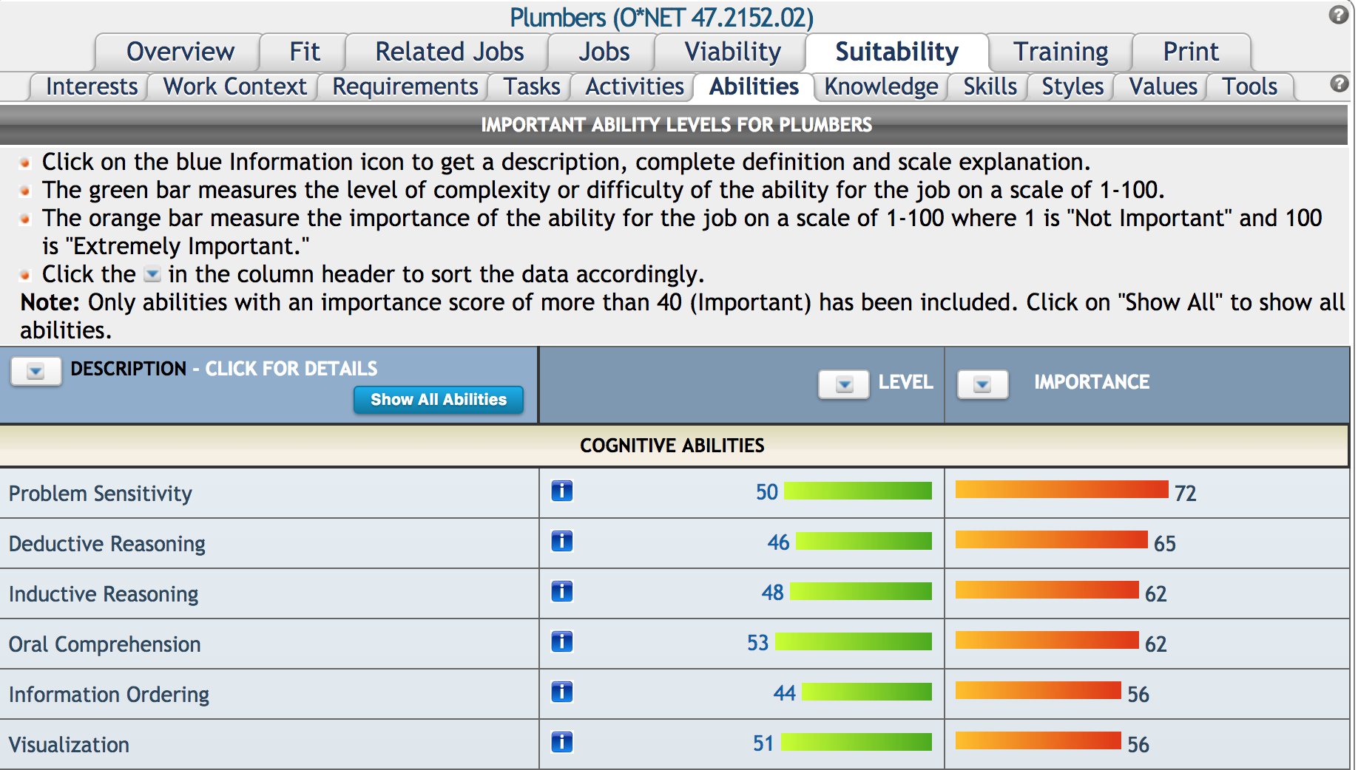
Capabilities may be either experience based (handling of a tough project demonstrated being a problem solver) or education based (obtaining a plumber’s license shows I have the capabilities of being a plumber). For purposes of TCI+, Capabilities may be found in the Suitability tab – Tasks, Skills, Knowledge, and Tools subtabs.
The Tasks subtab contains core and supplemental tasks for the selected occupation.
The Skills subtab contains required skills for the occupation.
The Knowledge subtab describes the type of knowledge required for the occupation.
The Tools subtab lists the tools and technology typically used on the job.
Interests have been categorized within TCI+ through the Holland Interest Inventory. Every occupation has a ‘Holland Code’ attached to it. There are many studies, tests, and usages of the Holland Code available on the internet. For purposes of TCI+, we use the codes associated with O*Net Online, which includes the categories Doer, Thinker, Creator, Helper, Persuader, and Organizer. For more information, visit: https://www.onetonline.org/find/descriptor/browse/Interests/
If you are unsure of your own code, O*Net Online has a useful test at: https://www.mynextmove.org/explore/ip

Concerns
When it comes to Concerns, there are a lot of possible items to consider. Here is a list of some, and how TCI+ may be used to address them?
Is the job a good fit for me?
Show the occupation on the IPE is a good fit by detailing how it is in line with the client’s Strengths, Resources, Priorities, Abilities, Capabilities, and Interests!
Am I qualified for this job?
In the Training tab, the Licenses and Certifications subtab will show required licensing in your state. Likewise, the Experience / Education subtab documents the experience and education most employers want their new hires to have.
Where can I obtain training to prepare for this job?
The Training tab – Schools subtab contains this data.
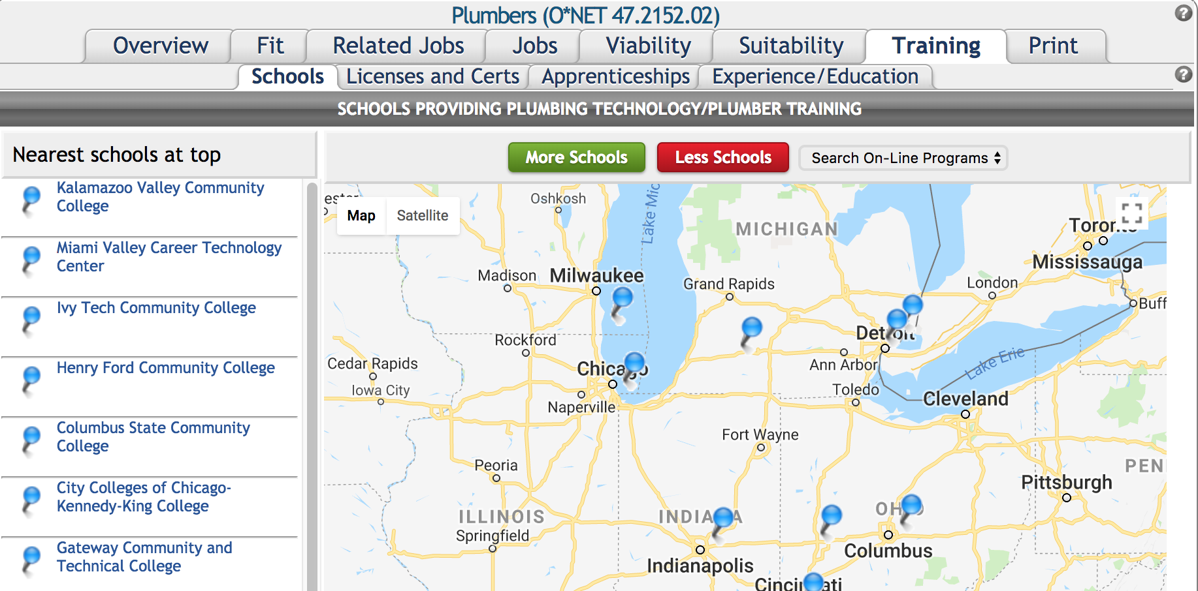
How will this job interact with my disability?
Under the Suitability tab, the Work Context sub-tab contains physical and social factors that influence the nature of work. This includes elements related to interpersonal relationships, physical work conditions, and structural job characteristics. Also under the Suitability tab, the Requirements sub-tab contains the cognitive, educational and physical requirements of the job as reported by employees to the Bureau of Labor Statistics.
If there are concerns identified within these two data sets, consider possible accommodations by visiting https://askjan.org/.

Labor Market Information
While TCI+ nor any program can guarantee employment opportunities, there is an abundance of labor market information (LMI) available to investigate. In thinking about how to systematically review available LMI, here is a model based on three important Career Pathways indicators: Job Availability, Upward Mobility, and Living Wage.
Job Availability
Does the market data support that the job will be available for the participant?
Question 1.1: How many jobs are currently posted in the area?
Question 1.2: What are some ‘related jobs’ that the participant may be interested in?
Question 1.3: What is the projected growth of this occupation (state level)?
Question 1.4: How many workers are in this occupation?
Question 1.5: How many openings occur each year?
Upward Mobility
Will the participant stay in this job forever, or will s/he have access to growth?
Question 2.1: What industries employee people in this type of job?
Question 2.2: What industries have the most growth potential?
Question 2.3: List three occupations that are require more skills and educational preparation than this job.
Question 2.4: What education, credentialing, or skills would benefit this client in pursuit of upward career mobility?
Question 2.5: Where would the participant obtain this education, credentialing, or skill?
Living Wage
Will the participant make a living wage by pursuing this employment?
Question 3.1: What is the wage range of this job?
Question 3.2: What education/work history/skills does the participant possess that would support a higher starting wage?
Question 3.3: Do most employees in this position work full-time or part-time hours?
Question 3.4: Does this position typically offer benefits or other perks?
The answers to these questions can be found throughout TCI+. We have identified these locations on the following page.

TCI+ Labor Market Information Locations
Question | Keyword | TCI+ Location
1.1 | Jobs in Area | Jobs tab (review postings)
1.2 | Related Jobs | Related Jobs tab – Related by Skill, Related by Interest subtabs
1.3 | Growth | Viability tab – Job Trends subtab
1.4 | # of Workers | Viability tab – Job Trends subtab
1.5 | Annual Openings | Viability tab – Job Trends subtab
2.1 | Industries Hires | Viability tab – Industries subtab
2.2 | Industries % Growth | Viability tab – Industries subtab
2.3 | Career Pathways | Related Jobs tab – Career Pathways subtab
2.4 | Credentials | Training tab – Licenses and Certifications subtab
2.5 | School Locations | Training tab – Schools subtab
3.1 | Wage Range | Viability tab – Wages subtab
3.2 | Experience/Skills | Training tab – Experience / Education subtab
3.3 | Full or Part Time | Overview tab
3.4 | Benefits and Perks | Jobs tab (review postings)
In Conclusion
The data presented above is meant to provide a VR professional a direct method of using The Career Index Plus (TCI+) to document how a vocational goal meets the unique strengths, priorities, concerns, abilities, capabilities, and interests of a VR participant, ultimately documenting the data found in the Individualized Plan for Employment (IPE). We are hopeful this guide has provided a new tool in the VR toolbox.

