TCI+ Profile Creation
These instructions will guide the VR professional on how to use The Career Index Plus to generate a profile and manage client activities within the system. To begin, go to www.TheCareerIndex.com and log into your account.

Creating a My Stuff Profile
The Career Index Plus can be used with or without a My Stuff profile; however, results will be most tailored to the user with an accurate, complete, and up-to-date My Stuff profile in the system.
To create a My Stuff profile, follow the steps below.
- From the Home screen, click on My Stuff.
- (First-time users only) Create a password.
- Once the password is created, click Submit.
- Click the Profile tab.
Note: Counselors may also follow these steps to simulate a client profile when working with a client without a My Stuff profile; however, counselors have reported that clients take a more active role in the career exploration, planning, and goal-setting process when they create their own profiles.

Profile Tab
The Profile tab consists of the Basics, Interest Profile, Work History, Career Clusters, Work Context, and Print Profile sub-tabs.

Basics
The Basics sub-tab contains basic information about the user. To complete this tab, enter the input fields (listed below), then click Save/Next.
Input Fields
ZIP code where you want to work
Are you over 21 years of age?
Desired Work Hours
Desired Work Type
How much are you looking to make in your next job?
Select highest training/education level attained
If you are planning for additional training/education, select level
Do you receive Social Security Benefits?

Interest Profile
The Interest Profile sub-tab consists of six questions based on the Holland Interest Profile. The answers to the questions result in a Holland Profile, a 1- to 3-character code that represents the user’s career and work preferences. Since each occupation has a correlating Holland code, completing this section gives the user an opportunity to find jobs that match based upon interests.
Category | Occupations Frequently Involve
Realistic (Doer) | Work activities that include practical, hands-on problems and solutions. Many of the occupations require working outside, and do not involve a lot of paperwork or working closely with others.
Investigative (Thinker) | Working with ideas, this position require an extensive amount of thinking. These occupations can involve searching for facts and figuring out problems mentally.
Artistic (Creator) | Working with forms, designs and patterns. They often require self-expression and the work can be done without following a clear set of rules.
Social (Helper) | These jobs require working with, communicating with, and teaching people. These occupations often involve helping or providing service to others.
Enterprising (Persuader) | Starting up and carrying out projects. These occupations can involve leading people and making many decisions. Sometimes they require risk taking and often deal with business.
Conventional (Organizer) | Following set procedures and routines. These occupations can include working with data and details more than with ideas. Usually there is a clear line of authority to follow.
To explore jobs that are related to the Holland Interest Profile, click the Show Related Jobs button, or to move to the next sub-tab click Next.

Work History
The Work History sub-tab lists the user’s previously held job titles. Users can skip this tab if they do not have any work history. Unpaid work experience such as internships and volunteerism can also be entered. To complete this tab:
- In the input field, enter a previously-held job title (or click on ‘Add job’).
- In the list of suggestions that appear, select the closest match.
- In the confirmation box that appears next, click Ok to save the title, or Cancel to enter a different title.
- Repeat Steps 1-3 until all of your job titles have been added.
- To receive recommendations based on your work history, select the radio button next to your favorite position.
The Career Index Plus will use this information to identify transferrable skills and recommend jobs that fit your skill set based on your previous work experience. For related jobs, click the Related Jobs button (blue) next to a title.

Career Clusters
Career Clusters contain occupations in the same field of work that require similar skills. Counselors, clients, and workforce partners can use Career Clusters to help focus employment plans toward obtaining the necessary knowledge, competencies, and training for success in a particular career pathway. In the Career Clusters sub-tab, clients can select (check) or deselect (uncheck) up to 16 career clusters. By default, all clusters are selected. To explore jobs within a particular career cluster, select the Related Jobs button next to the career cluster.

Work Context
In this sub-tab, clients can select their preferences for up to 55 Physical Factors, Stress Factors, Interactions with Others, Work Environment, and Other contextual factors that could be encountered within an occupation. When a limitation is selected, the screen will provide the percent of all occupations that typically require a higher level than what was selected. Making a selection within this sub-tab will not limit the Recommended occupations, but will provide an alert if a searched for occupation requires a higher level of ability than what was selected in the profile.

Print Profile
The Print Profile sub-tab contains the client’s My Stuff profile (i.e., the selections made under the Basics, Interest Profile, Work History, Career Clusters, and Work Context sub-tabs). Clicking the Print button opens the browser’s print dialogue box, which includes options to save the information as a PDF, and/or print the information.
This concludes a description of the data within the profile section. The next areas contain information about the recommendation of jobs and saving occupations for comparison.

Recommended Occupations
The Recommended tab provides job recommendations based on the user’s profile and preferences. After answering the questions on the Recommended tab, clicking Show Matches provides a list of recommended occupations based on the user’s profile. To view a list of saved occupations, click the Saved Occupations button.
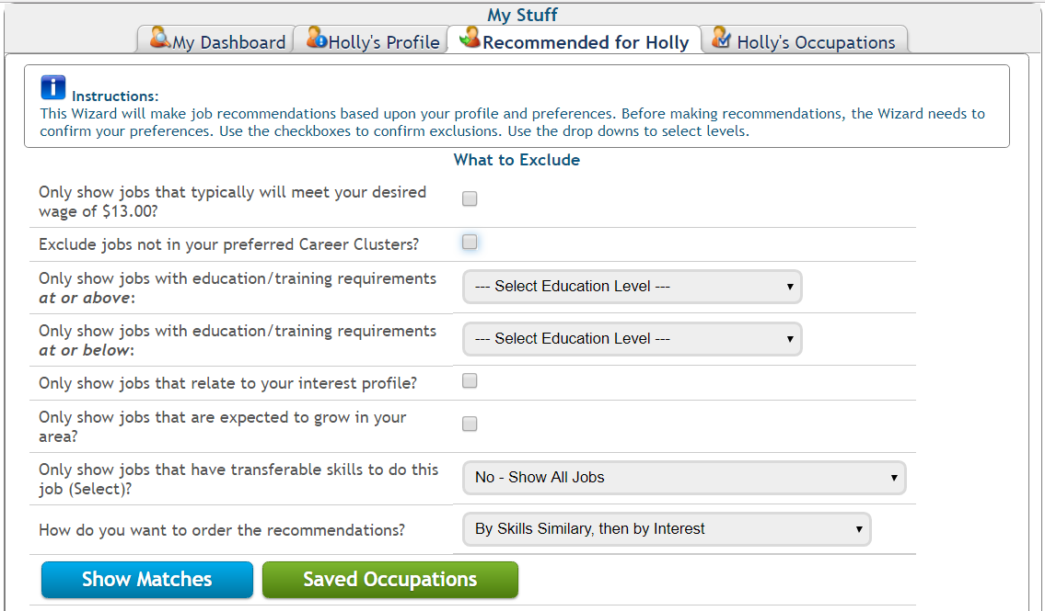
After clicking Show Matches, a Recommended Occupations table will load at the bottom of the screen. If no entries appear, try adjusting the number and/or type of exclusions in the data fields above.
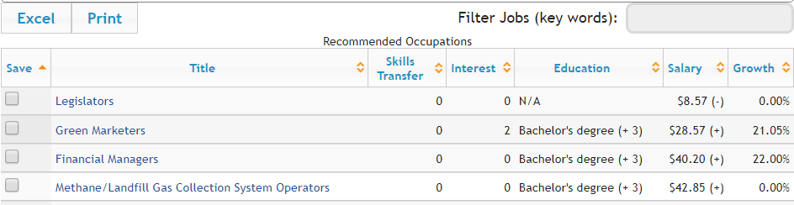
To save an occupation for further review, click the small checkbox to the left of every job. This will save the job into the Saved Occupations area.

Saved Occupations
The Saved Occupations tab provides a list of previously saved occupations. Clicking on an occupation provides detailed information about the occupation. Or, clicking ‘Compare Occupations’ will provide a comparison of important data points for each occupation listed.
Comparison information will load underneath the Compare Occupations button. A default report will provide a compassion of the Definition, Wage Comparison, Job Openings, Growth, Education & Experience, and Key Employment Factors for the jobs listed. It is also possible to customize this report with any of the other data points available in the system.
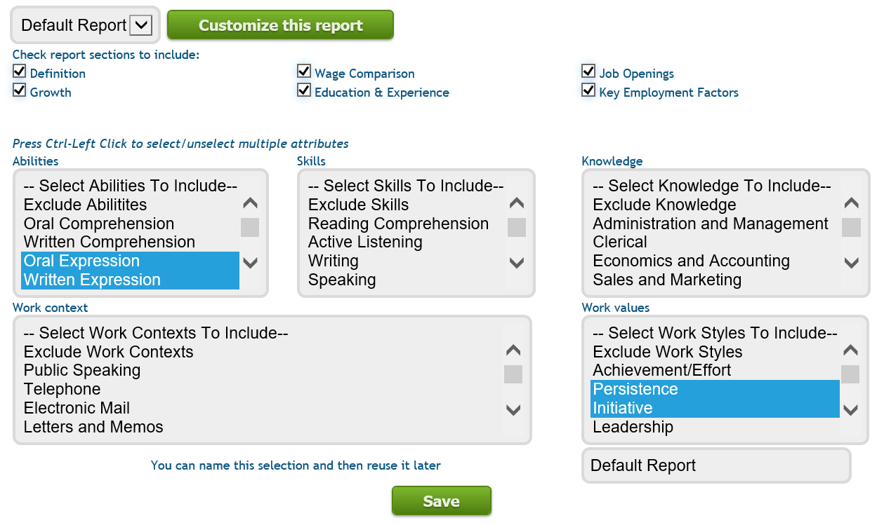
After reviewing the occupations and comparing their employment factors, the user may Print this information to a PDF and save it into the casefile.

Viewing & Updating a My Stuff Profile
Maintaining a complete, accurate, and up-to-date My Stuff profile will produce the most relevant recommendations and Fit information. The My Stuff button at the top right corner of every screen within The Career Index Plus can be used to access the profile. When a profile is changed, the information under the Recommended and Fit tabs automatically update according to the new profile.
If you have recommendations for how to make the profile more useful, please let us know by posting a comment using the comment link at the bottom of every screen.

