VR Client Self-Guided LMI Study
The Career Index Plus is a website (Visit it here: www.thecareerindex.com) that gives you information about jobs. This information -- Labor Market Information (LMI) -- will help you communicate your informed choice to your VR Counselor.
How much does a job usually pay? How much experience do I need? What type of activities do people do in this job? Why is this job a good fit for me? The Career Index Plus can help you answer all these questions and more.
- Go to www.TheCareerIndex.com

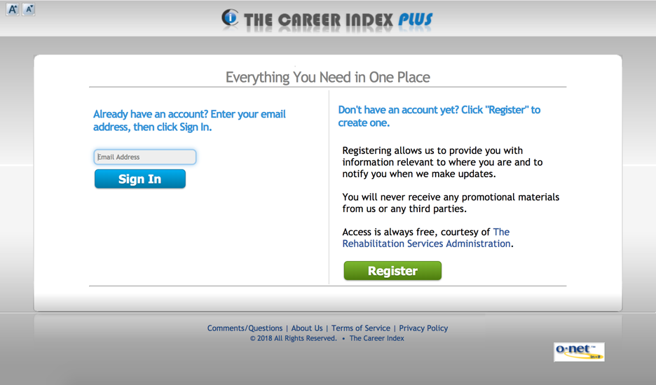

- Click on Register (the green button) to get a log-in. Fill in your information and click Create Account.

- In the Keyword(s) section, type a career or interest and click Search.
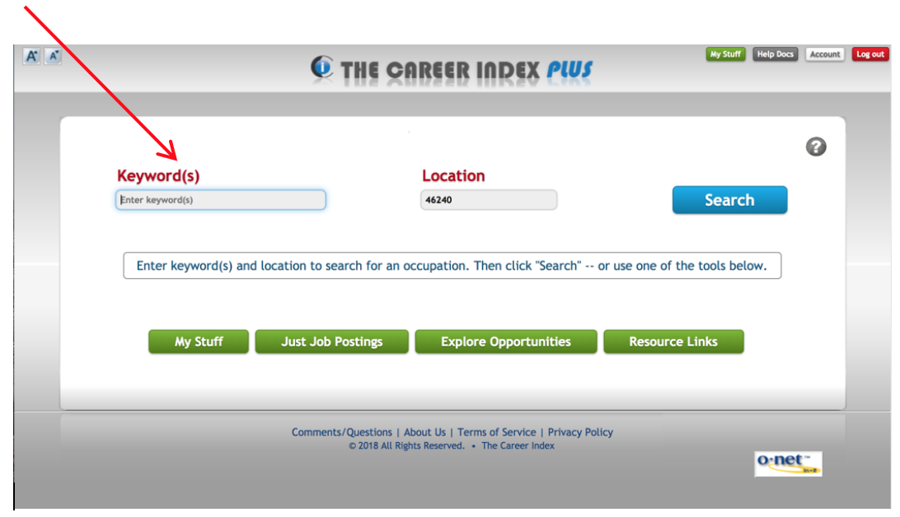

- From the list of careers provided, choose the one you would like to research. (Note: There are many careers with similar names, so make sure you have selected the one in which you are interested.

- You are now on the Overview page, which contains a description of the career, typical qualifications, information about the work environment, national and state job outlook (growth rates), job postings and typical wages.

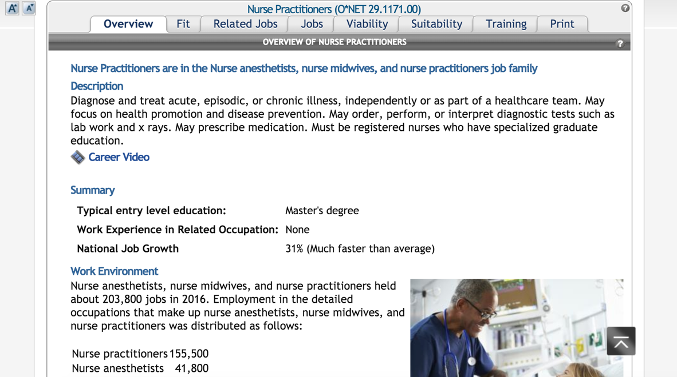

- Click on the Related Jobs tab to give you a list of jobs that are similar to the one you are currently researching.

- Click on the Jobs tab to search for open positions in that career field.

- Click on the Viability tab to get wages, job trends (how many openings) and what types of businesses are hiring.

- Click on the Suitability tab to get information about the career -- interests, job duties, abilities used in the career, useful knowledge, skills that may be needed, personality characteristics for the career, values and tools used on the job.

- Click on the Training tab to learn what education may be needed.

Now that you have become familiar with the website, please answer the questions on the attached page to learn more about the job in which you are interested.
Name: Phone/Email:

Job Name: Zip Code Searched:

Question 1: What is the description of this job? What does the position involve?

Question 2: How many jobs are currently posted in your area?

Question 3: What is the projected growth of this occupation?

Question 4: What industries employ people in this type of job?

Question 5: What is the wage range of this job?

Question 6: What are the most important activities this position does?

Question 7: How much experience is typically needed for this job?

Question 8: Based on the things above, why does this job seem like a good fit for you?

