Everything You Need in One Place, Everything in One Search

Vocational Rehabilitation Counselor Manual
(Updated September 1, 2017)

Contents
Introduction 8
Intent of the Workforce Innovation and Opportunity Act 8
Enhanced Agency Effectiveness 9
Enhanced Counselor Effectiveness 10
Enhanced Client Choice 10
Example 11
Historical Factors Impacting the Ethics of Labor Market Information 12
Ethical Considerations in the Use of Labor Market Information 14
Example 17
Additional Information about Labor Market Information in VR 17
About The Career Index Plus 18
The Career Index Plus Quick Start Guide 19
Quick Start Option 1: Conducting a Basic Search 20
Job Title/Occupation Information 21
Job Listings 21
Quick Start Option 2: Creating a My Stuff Profile 21
Other Quick Start Options 22
How The Career Index Plus Works 22
How to Use This Manual 23
Technology Requirements 24
Accessibility 25
Navigating within The Career Index Plus 25
Input Fields 25
Buttons 26
Tabs 26
Links 26
Help Content 26
Returning to the Home Screen 27
Minimizing Scrolling 27
Contacting The Career Index Team 27
Account Management 27
Creating an Account 27
Counselor Account Creation (first-time user only) 28
Client Account Creation (first-time user only) 29
Logging In 29
Viewing & Updating Account Information 29
Configuring What Information is Displayed in TCI 30
Logging Out 30
Adding and Tracking Clients 30
Adding a Client 31
The Client Experience 31
Tracking Client Progress 33
My Clients 33
Accessing a Client’s Profile 34
Removing a Client from Tracking 35
Getting Started 35
Creating a My Stuff Profile 35
Profile Tab 36
Recommended Occupations 42
Saved Occupations 46
Viewing & Updating a My Stuff Profile 49
Searching for Labor Market Information 49
Search Types 49
Job Search Terms and Tips 50
Keyword(s) 50
Location 51
Searching for an Occupation 52
Occupation Information 53
Overview 54
Fit 56
Related Jobs 59
Also Known As 59
Related By Skill 59
Related By Interest 60
Career Pathways 61
Transitions 62
Jobs 63
Searching Indeed® Directly 66
Conducting an Advanced Search 66
Building and Posting a Resume 66
Viability 67
Wages 68
Job Trends 69
Industries 70
Suitability 71
Interests 72
Work Context 72
Tasks 73
Activities 74
Abilities 75
Knowledge 77
Skills 78
Styles 79
Values 79
Tools 80
Training 80
Schools 81
Licenses and Certifications 83
Related Training 83
Experience/Education 84
Printing, Emailing, or Saving a Report 85
Viewing and Printing a Report 86
Emailing a Report 87
Downloading and Opening a Report 88
Just Job Postings Search Information 89
Conducting a Just Job Postings Search 89
Just Job Postings Search Results 89
Additional Resources 90
Disability Resources 90
Ex-Offender Resources 90

Introduction
In today’s rapidly changing economy, making a good career decision is more challenging and important than ever. A fundamental key to success is access to relevant, actionable information. The Career Index Plus is an online career information system providing all the information and resources needed to help clients make informed career choices.
The makers of The Career Index Plus set out to help Vocational Rehabilitation counselors do what they do best -- counsel! With The Career Index Plus, counselors can better assist clients in making informed choices about their right to pursue a meaningful career, with respect for self-determination, while promoting full inclusion and participation in the mainstream.
The Career Index Plus is free to all users, thanks to a grant from the Rehabilitation Services Administration aimed at helping VR agencies successfully implement the requirements of the Workforce Innovation and Opportunity Act.

Intent of the Workforce Innovation and Opportunity Act
The purpose of the Workforce Innovation and Opportunity Act (WIOA), as stated in Public Law 113-128, is:
To amend the Workforce Investment Act of 1998 to strengthen the United States workforce development system through innovation in, and alignment and improvement of, employment, training, and education programs in the United States, and to promote individual and national economic growth, and for other purposes.
The WIOA regulations address the effective use of labor market information to support clients in selecting and sustaining quality employment. The level of labor market information understanding needed by vocational rehabilitation professionals is described as “a 21st century understanding.” Regulations (§361.18) indicate that “21st century” refers to maintaining a cutting edge, state-of-the-art approach, rather than merely maintaining activities at traditional, established levels.
WIOA requires that vocational rehabilitation agencies use labor market information for the following activities:
- Vocational rehabilitation counseling
- Provision of information to clients for the purposes of making informed choices
- Business engagement
- Business relationships
- Job development
- Job placement
- Responding to today’s labor market
The Career Index Plus is a tool that can assist vocational rehabilitation professionals in meeting this requirement.

Enhanced Agency Effectiveness
The Career Index Plus can support leadership and management of vocational rehabilitation agencies in the following areas.
- Identifying in-demand industries and occupations for specific geographical areas
- Analyzing employers' needs in industries and occupations
- Identifying educational and skill levels needed for specific industries or jobs
- Identifying potential partnership opportunities with businesses

Enhanced Counselor Effectiveness
The Career Index Plus can support counselors in understanding labor market dynamics that impact job searches and career choices. Using The Career Index Plus, counselors and clients can incorporate labor market information into career counseling discussions.
Counselors can support clients in evaluating options:
- Considering opportunities from an economic/wage perspective
- Considering opportunities from a geographical/location perspective
- Identifying skills that need to be developed for a specific job or career
- Identifying specific training needs and corresponding training opportunities specific to a career choice
- Combining labor market information with the client’s interests, likes, and dislikes, to enhance decision-making
The Career Index Plus can be used in the development of an Individualized Plan for Employment (IPE) and can streamline the assessment process.

Enhanced Client Choice
Vocational rehabilitation clients sometimes have limited exposure to a wide variety of career and job options. Features of The Career Index Plus can assist to expand thinking about what can be possible for each client. The key concept to keep in mind is the use of labor market information to expand (rather than to limit) choice.
Some people using vocational rehabilitation services may lack understanding or have outdated notions of the workforce. They may believe opportunities in a certain occupation are more prevalent than they actually are, or that a given occupation is more lucrative than it actually is. They may have an unrealistic understanding of the skill sets and requirements needed to start or advance in a certain career. The Career Index Plus can be used to expand understanding of the labor market and take such information into consideration.
Labor market information should be used to enhance client choice, not to create a “dead-end” to discussion. Clients can use The Career Index Plus to explore questions such as the following.
- What occupations are in demand in the geographical area where I want to work?
- Is the demand for this kind of work increasing or decreasing?
- Might there be opportunities for advancement if I select this job or career?
- How much training or education would I need for this job or career?
- Are there other jobs that have similar characteristics that I might consider?
Different features of The Career Index Plus can be used to promote a deeper understanding of labor market information while working to develop a successful career plan.

Example
A client is using The Career Index Plus and the search results produce a limited number of job opportunities for the specified geographical area. The client shares these disappointing results with his/her counselor.

What Not to Do
This should not be a “dead-end” to the discussion. Do not guide the discussion toward a lesser goal, such as “there are no opportunities here, but maybe you would be willing to accept....”

What to Do
Quality counseling skill becomes essential to effectively use The Career Index Plus (or any labor market information tool) to enhance client choice. Various facets of the client’s original job interest can be explored with the client.
- The client may want to consider relocation if there are more opportunities for that job choice in a different area of the country.
- It is possible that work in a different setting or related profession could be considered.
- Perhaps, it is not the particular job that interests the person, but rather the industry in general (e.g., someone interested in theater may not need to be an actor, but may enjoy helping to build the set).
By continuing the discussion, it can be motivating for the client to understand that there are always options.

Historical Factors Impacting the Ethics of Labor Market Information
Subtle, yet significant, ethical factors must be considered when introducing labor market data (from any source) into the counseling and career decision-making process. The history of vocational rehabilitation practice shows how information can be used to expand or to (advertently or inadvertently) limit client choice.
Historically, vocational rehabilitation services were based on a “medical model” in which the counselor was seen as the authority in decision-making. This contributed to a power differential between client and counselor, and often resulted in the client deferring to the counselor’s judgment as to what was an appropriate vocational goal. The reauthorization of the Rehabilitation Act in 1998 called for and expanded the practice of “informed choice” in the provision of vocational rehabilitation services. This act required state agencies to develop policies and procedures that would ensure individuals with disabilities were provided with the information and supports necessary to exercise informed choice.
This was applicable throughout the entire vocational rehabilitation (VR) process, beginning with assessments for eligibility, and continuing through the selection of vocational goals, services, and service provider(s). The reauthorization also positioned individuals with disabilities as active partners in developing their rehabilitation plans. Clients had the option to develop their own plan, invite a representative to assist them, or to collaborate with a qualified VR counselor.
For more information about the amendments to the Rehabilitation Act of 1998, see Information Memorandum RSA-IM-98-20, The Rehabilitation Act Amendments of 1998 online at http://www2.ed.gov/policy/speced/guid/rsa/im/1998/im-98-20.pdf.
In VR today, this active partnership takes the form of rapport-building based on mutual respect and increased collaboration between clients and counselors. As professionals, however, VR staff are aware that they still hold a relative position of authority. To a large extent, the counselor determines what information the client receives regarding VR processes and services. Caseloads, time, and competing responsibilities can also contribute to a counselor’s influence on client decision-making.
H.H. Strupp (1980) wrote that the counselor’s personal and professional value system can influence the course of the counseling process. Whether by providing specific direction, or through subtle verbal and nonverbal cues, counselors can influence what topics will be discussed, what will be addressed in the counseling relationship, and what goals are considered possible or appropriate. It is important that the counselor be aware of his or her own priorities, values, and belief systems when counseling clients who may have different values, needs, and motivations for choosing a certain vocational goal.
Consider, for example, a client who wants to be an artist, with a counselor who believes that opportunities for artists are limited. If the counselor believes that the client should support himself by taking a job where there are more job openings, and attempts to steer the client away from his choice of being an artist, this could result in the imposition of the counselor’s values on the client. The use of labor market information, in this example, could be used to either limit, or expand opportunities for the client.
With the goal of expanding opportunities, The Career Index Plus can be used to guide the client’s exploration of both traditional and non-traditional job choices. It contains current and objective information that, with the right training and practice, can provide a foundation upon which the client can make an informed decision. In the artist example above, the informed choice process would involve equipping the client with labor market information, such as job outlook and growth projections, median wages, similar or related jobs, career pathway information, etc., for the client to choose whether he would prefer to continue becoming an artist, or to change course.
Communicating the belief that the client has the ability to achieve success with a skillfully chosen career goal is essential to empowering clients to set goals and make choices that will lead to employment success.

Ethical Considerations in the Use of Labor Market Information
Helping clients interpret and use labor market information (LMI) has ethical implications. Labor market information should be used to promote a client’s informed choice; it should not be used to direct the choice.
If you are credentialed as a Certified Rehabilitation Counselor, then you are familiar with the code of ethics from the Commission on Rehabilitation Counselor Certification (CRCC). The code of ethics is designed to create a standard to “…assure the public that the rehabilitation counseling profession accepts its responsibility to provide caring service to individuals with disabilities.” The code is comprehensive and covers an array of aspects encompassed in the counseling relationship. While the code does not specifically refer to LMI, the values and principles reflected in the code have direct relevance to this topic.
Welfare of clients. It is important that the LMI considerations and discussions are done in light of the client’s interests, aptitudes, abilities, education level, etc., to assure that clients have the understanding to effectively use the information in their decision-making. Additionally, counselors are cautioned to avoid imposing their values, attitudes, and beliefs in terms of helping the client interpret the information.
Advocacy and accessibility. Work to identify barriers based on the functional limitations of clients and to assure that LMI is rendered to clients in an accessible format (i.e., in terms of sensory and cognitive accessibility) and that they are able to interpret and understand the results and implications.

Professional responsibility. It is the counselor’s responsibility, with support of management, to participate in training in order to acquire competency in the use of the tool and the resulting data. Training should include access and use of the tool, interpretation of the data, and the ability to explain the results.
Use of technology. It is important to caution clients on the limitations of labor market information (LMI) data to mitigate potential misunderstandings related to its application.
Encourage clients to have a balanced perspective about the advantages and limitations of LMI gained through The Career Index Plus or any LMI tool. Career trend information that populates The Career Index Plus is derived from multiple governmental sites. Data elements may not reflect today’s most current trends. Labor market information is ever changing and updating, so no report is written in stone.
Even “real-time” labor market information does not account for fluctuations in how frequently the original poster of the information is updating and assuring accuracy. Additionally, there are many viable job opportunities that are never posted on the internet, so are never pulled into “real-time” labor market reports. Your connection with your business account staff and/or your relationships with businesses will remain essential to ensure broad-based opportunities for your clients.
While working with The Career Index Plus, as with any LMI source, be vigilant in interpreting the information with clients. Take, for example, the information on the Suitability tab. A series of sub-tabs provides information that can be considered as a client begins to make judgement calls about the “suitability” of a job or career. However, the information in these sub-tabs does not factor in potential accommodations and creative strategies. Counseling expertise will be critical to these considerations when reviewing job descriptions and other job-specific information to determine whether modifications can be made on behalf of the client. While The Career Index Plus can provide value and save counselor time, it is important to note that labor market information is a component of informed choice, and is not the choice itself.

Example
Suppose a client is reviewing the occupation of “Tour Guides and Escorts.” On the The Career Index Plus Suitability tab, there is a sub-tab labeled Work Context. On that tab, there is an indication that “Spend Time Standing” is “about half the time.” While standing “about half the time” might be typical for this job, the need to stand frequently can be modified or accommodated. This is where counselor experience and creativity will come into play. Reviewing labor market information, while being mindful of potential modifications or mitigating factors, can serve to create opportunities that may not be apparent at first glance.

Additional Information about Labor Market Information in VR
For additional information about using labor market information in vocational rehabilitation, visit the ExploreVR Labor Market Information Toolkit online at http://www.explorevr.org/toolkits/labor-market-information.

The following webinars are available from the toolkit, along with information about metrics, uses, and additional resources.
- Overview of Labor Market Information for Vocational Rehabilitation Services
- Introduction to Labor Market Information in a Job Driven Economy. An overview of how VR agencies use LMI throughout various levels of the agency to inform their work with the dual customer.
- Sector Strategies: What Are They and How Can They Help VR Agencies?
The impact of LMI on developing sector-based strategies for employer engagement.

About The Career Index Plus
The following are some of the uses for The Career Index Plus within the field of vocational rehabilitation and the workforce system:

- Promoting informed choice
- Decision-making based on labor market information
- Career exploration and counseling
- Identification of career pathways
- Transition planning
- Pre-employment transition services
- Customizing employment
- Conducting a comprehensive assessment
- Identifying transferable skills and related occupations
- Developing an individualized plan for employment
- Identifying training and education needs and providers
- Identifying credentialing requirements
- Searching and applying for jobs
- Accessing the “hidden” labor market
- Preparing for informational interviews
- Preparing for job interviews

The Career Index Plus Quick Start Guide
The purpose of The Career Index Plus is to provide you with everything you need in one place to make an informed career choice. It is completely free to all users.
Signing in will bring you to the Home screen:
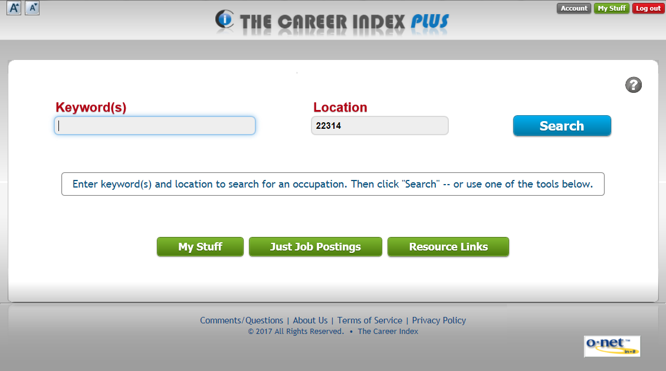
To return to the Home screen from any other screen within The Career Index Plus, click on the The Career Index Plus logo at the top of the screen, or the Home button.
There are two ways to get started quickly using The Career Index Plus.
- To quickly find information about an occupation, including job openings, salaries, training, and more, conduct a Basic Search (see Quick Start Option 1: Conducting a Basic Search on page 20).
- To personalize The Career Index Plus to help you find and evaluate occupations depending on your needs and circumstances, start by creating a My Stuff profile (see Quick Start Option 2: Creating a My Stuff Profile on page 21).

Quick Start Option 1: Conducting a Basic Search
From the Home screen, enter a Keyword(s), enter a Location, and click Search.
The results screen will display a list of related occupations, with the closest match listed first.
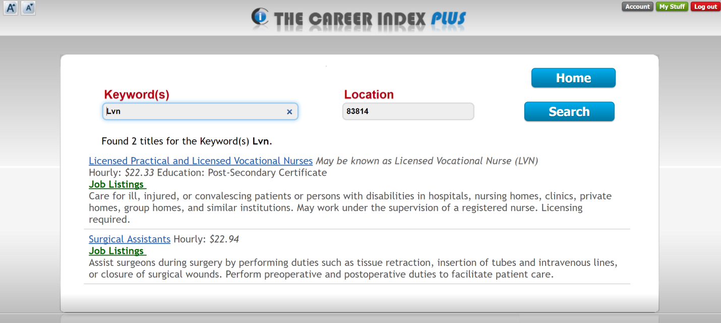
Clicking on a job title (blue) will provide detailed information about the occupation. Clicking on Job Listings (green) will provide a list of job openings in the specified location.

Job Title/Occupation Information
After clicking on a job title, the available information for the occupation is presented in tabs. Click on the tabs to access the information, or click the Print tab to download, email, or print the information in a report.
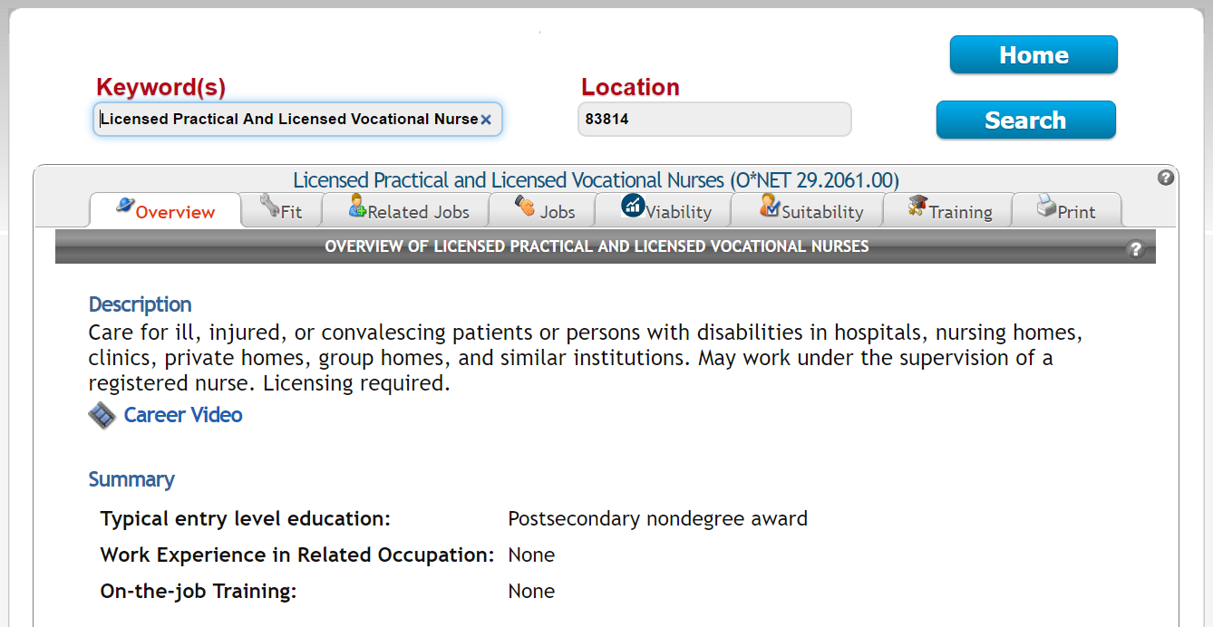

Job Listings
From the results screen, after clicking Job Listings, you can also modify your search parameters and click Search, search from Indeed® directly, conduct an advanced search, or post a resume online.

Quick Start Option 2: Creating a My Stuff Profile
From the Home screen, click on the My Stuff button (green), and create a password. Then, click on the Profile tab, and complete each sub-tab from left to right, starting with Basics, and ending with Work Context. You can skip any sub-tabs that do not apply to you.
Once your My Stuff profile is complete, click on the Recommended tab for a list of occupations based on your profile. Whenever you find a list of occupations in The Career Index Plus with a check-box next to it, checking the box saves the occupation to the Occupations tab. From there, you can compare occupations and print comparison reports.

Other Quick Start Options
From the Home screen, clicking on Just Job Postings allows you to search for positions that are currently posted on Indeed®.
From the Home screen, clicking on Resource Links provides additional resources for individuals with disabilities and ex-offenders.

How The Career Index Plus Works
Picture an hourglass. The Career Index Plus begins with a wide scope, slowly narrowing down the user’s focus to a specific occupation using work history, interests, education/training, and a host of other criteria. Once a career is chosen for further exploration, The Career Index Plus provides a wealth of information and opportunities related to the selected job family.
The Career Index Plus includes labor market information from all 50 state Labor Market Information (LMI) divisions plus The Bureau of Labor Statistics, O*NET OnLine, Career InfoNet, the U.S. Department of Labor, and more. As the primary source of occupational data for the United States, the Occupational Information Network (O*NET) is the primary backbone of The Career Index Plus system.
O*NET, sponsored by the Employment and Training Administration (ETA) of the U.S. Department of Labor, contains the most comprehensive and detailed database of occupations available anywhere. The O*NET taxonomy is the official occupational structure used by the United States government and many private organizations. A large number of government statistics are crosswalked to O*NET codes, including labor market projections, industry forecasts, training programs, salary surveys, licenses, certifications, etc.
Additional labor market information, job ads, and resume services on The Career Index Plus are provided through Indeed®. As the world's #1 job site, with over 180 million unique visitors every month from over 60 different countries, Indeed® has become the catalyst for putting the world to work.
The Career Index Plus is free for all users, thanks to a grant from the Rehabilitation Services Administration.

How to Use This Manual
Counselor and consumer time is valuable. For use as a quick reference guide, each section of this manual may be read independently of the others. If using the computer-based version of the manual, hold down the Ctrl key and click on a topic in the Table of Contents to jump to that section of the manual. When another section is referenced in the body of the manual, hold down the Ctrl key and click on the page number to jump to the referenced section. For a comprehensive overview of all the capabilities of The Career Index Plus, this manual may also be read cover-to-cover.

Looking for specific types of information? Find it quickly and easily with the following icons.
Icon | Description
 | Identifies tips for counselors to help make the most use of The Career Index Plus with clients. These tips also apply to job coaches, clinicians, educators, mentors, etc.
 | Identifies resources for further exploration related to a specific topic.
 | Identifies tips and tricks for intermediate and advanced users of The Career Index Plus.

Technology Requirements
The Career Index Plus can be used from any device with an internet connection and download speeds of at least 1 megabit per second (mbps). Make sure the device does not block outside links, and that JavaScript and cookies are enabled.
You do not have to speak “Tech” to use this resource. If users do not have the required technology, the screen will alert them when they go to the website, and it will prompt them through the steps needed to move forward.

Accessibility
The Career Index Plus adheres to WCAG 2.0 AA accessibility guidelines and works with most standard computer accessibility tools and assistive technology devices. Additional accessibility measures include the following:
- Buttons on every screen that can be used to increase and decrease font size.
- A screen reader setting that is available to select during account creation, and from the Account management screen.
- Videos that include both sound and captions.

Navigating within The Career Index Plus
The Career Index Plus looks and works similarly to popular search engines and job boards like Google and Indeed®, but also contains a much deeper layer of information. Navigating within The Career Index Plus is quick and easy with the following features.

Input Fields
Input fields appear gray with gray text that asks for a specific type of information for a user to enter. Sometimes, an input field will autofill, or make suggestions, based on what the user enters. Users can either click on a suggestion, or continue entering the desired information.
The autofill feature can save time. Sometimes, just typing a few letters will provide the desired information. If what you are looking for does not pop up, just keep typing.

Buttons
Buttons appear blue, gray, red or green with white text. Clicking a button tells The Career Index Plus what to do next.

Tabs
Tabs at the top of a web page or section within The Career Index Plus help organize information by topic. Tabs can be used in order from left to right, or out of order to skip to a specific topic. Some tabs may contain additional sub-tabs.

Links
Links lead to additional information about a specific topic. Some links go to a new page within The Career Index Plus. To get back to the previous page, click the browser’s Back button. Other links open a new tab within the browser window. Upon notification that this will happen, click Ok to open the new window, or Cancel to stay within The Career Index Plus. To get back to The Career Index, close the window.
The following notification will appear before opening a link to another website.
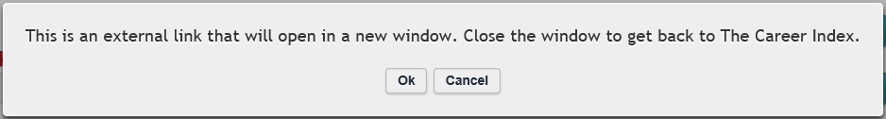

Help Content
The Help icon ( ) provides more information to help understand or navigate what is on screen. This information can be printed as a job aid, handout, or quick reference card for users.

Returning to the Home Screen
The Home screen is the first screen after logging in to The Career Index Plus. From any other screen within The Career Index Plus, clicking the Home button
( ) or the The Career Index Plus logo ( ) jumps to the Home screen.

Minimizing Scrolling
Some screens require scrolling to see all the information. When the Scroll To Top button ( ) is present, it can be clicked in order to jump back to the top of the screen.

Contacting The Career Index Team
The Comments/Questions link appears at the bottom of every screen. Click here to send comments/questions to The Career Index team or to request technical support.

Account Management

Creating an Account
To use The Career Index Plus, each user creates an account. Counselors and clients should each use their own accounts. New users need only create an account once. Once an account is created, users need only their email address to log in.

Counselor Account Creation (first-time user only)
To create a counselor account, follow the steps below:
- Go online to www.thecareerindex.com.
- On the right side of the screen, click Register.
- On the right side of the screen, enter your first name, last name, official work email address, and ZIP code.
- If you use a screen reader, check the box below the ZIP code.
- In the drop-down menu, select the option that best describes your user type.
Vocational Rehabilitation Counselors who log in to The Career Index Plus with an official work email address can use the My Stuff feature to create client accounts, invite clients to use The Career Index Plus, and track client progress. Workforce partners may also request this functionality through the Comments/Questions link at the bottom of any screen within The Career Index Plus. See Adding and Tracking Clients on page 30 for more information.
- Click Create Account.

Client Account Creation (first-time user only)
To create an account for a client, see Adding and Tracking Clients on page 30. Alternatively, clients can create an account manually with the following steps.
- Go online to www.thecareerindex.com.
- On the right side of the screen, click Register.
- On the right side of the screen, enter your first name, last name, email address, and ZIP code.
- If you use a screen reader, check the box below the ZIP code.
- In the drop-down menu, select the option that best describes your user type.
- Click Create Account.

Logging In
Once an account has been created, returning users can log in online at www.thecareerindex.com.

Viewing & Updating Account Information
The Account button ( ), located at the top right corner of every screen, can be used to update the user’s account information. This includes the user’s email address, name, ZIP code, share settings, user type, and screen reader setting. Users can also select the type of information that is displayed in their account.

Configuring What Information is Displayed in TCI
The Configure what information is displayed in TCI link can be used to select the type of information that is available when clicking on an occupation title. Major categories include Occupational Summary Information; Occupational Fit; Related Occupations; Job Openings; Wages, Trends, and Industries; Occupational profile information including Knowledge, Skills, and Abilities (KSAs); Training, licenses and experience requirements; and Print Menu. Some major categories also include subcategories to choose from. Checked categories and subcategories will be displayed, while unchecked categories and subcategories will not.

Logging Out
The red Log out button ( ) appears at the top right corner of every screen within The Career Index Plus. Click Log out before closing the browser window or logging in another user.

Adding and Tracking Clients
Vocational Rehabilitation Counselors who log in to The Career Index Plus with an official work email address, and workforce partners who request access to the My Clients feature can create client accounts, invite clients to use The Career Index Plus website, add clients for tracking, track client progress, and import client profiles.

Adding a Client
Adding a client allows a counselor or workforce partner to create a client account, invite the client to use The Career Index Plus, and ask permission to access the client’s profile and usage information.
- From any screen within the counselor’s account, click on My Stuff.
- Enter your password and click Submit.
- Click My Clients.
- Click Add Client.
- Follow the on-screen instructions.
- Repeat for additional clients.

The Client Experience
If the Invite Client option is selected, the client will receive an email invitation containing a link to The Career Index Plus. If the email invitation has not been received within 10 minutes of sending it, have the client check his or her “junk mail” email folder.
Clicking the link opens the The Career Index Plus login screen with the client’s username prefilled. When the client accesses The Career Index Plus for the first time, s/he will be asked permission for the counselor to access his/her profile and usage information. If the client does not provide permission, the counselor will not be able to access this information.
If the client account has previously been added to the counselor’s account, re-adding the client account and obtaining permission will update the profile and usage information that is accessible to the counselor.

A client account may only be linked to one counselor account at a time. When the client provides permission to share profile and usage information with a counselor, it will automatically discontinue permission for the previous counselor or workforce partner.
Clients cannot view any of the counselor’s account information, nor can they view any other client’s information.
If the Create Client, No Invite option is selected, it will not create a client account or send an email invitation, but it will create a client profile that will be accessible only via the counselor’s account (or other staff that the counselor is authorized to share information with).
A counselor account has some added features that client accounts do not have. If you want to see what an invitation from you or a client account looks like, try adding yourself as a mock client using your personal email address (see Adding and Tracking Clients on page 30).

Tracking Client Progress
To track client progress, click the My Stuff button from any screen, enter your password, and click the My Clients tab.

My Clients
If a client has been added to the counselor’s account, the list of all currently tracked clients appears on the My Clients tab above the Add Client section.
Next to each client’s name and email address, the counselor has data on whether the client’s My Stuff profile is available -- i.e., whether the client has provided permission for the counselor to access his/her profile and usage information (see Creating a My Stuff Profile on page 35), when the client account was created, whether and when the client was invited, when the client last visited The Career Index Plus, how many activities the client has completed, and how many times the client has visited The Career Index Plus (total visits). A Stop Tracking column allows the counselor to discontinue his/her access to the client’s profile and usage information.
Clicking on a client name shows the client’s activity history. The Client Activity History table displays the date(s) that the client logged in and a brief description of his or her activity on each date. Table content can be sorted by column heading. It can also be searched using the Search field at the top right corner of the table. Underneath the table, users can select the number of entries to show, and navigate through multiple pages (if applicable). Buttons above the Date column allow counselors to export the information to Microsoft Excel, download a PDF, or print the information.

Accessing a Client’s Profile
If a tracked client has created a My Stuff profile (see Creating a My Stuff Profile on page 35) in his or her client account, a counselor can import the client profile by clicking the Switch to Profile option above the Client Activity History table (see Tracking Client Progress on page 33). This feature may be used if working alongside a client, or when preparing for client-specific services.
Once a client account has been imported, all screens within the counselor’s account will show the same information the client would see based on the client profile. For example, clicking the Profile tab from the counselor’s account would show the client’s profile. Clicking the Occupations tab from the counselor’s account would show the client’s saved occupations. Similarly, results on the Fit screen would show Fit in relation to the client’s profile (see Fit on page 55).
To import a different profile, return to the My Clients screen (see My Clients on page 33), click on a different name, and click Switch to Profile button.
To create a new profile for a client that is not currently being tracked, return to the My Clients screen, click on Add Client, and follow the instructions to Create Client, No Invite (see The Client Experience on page 33).

Removing a Client from Tracking
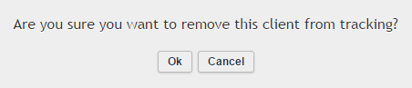
To stop tracking a client, return to the My Clients tab (see Tracking Client Progress on page 33), and check the box under the Stop Tracking column. This will prompt the following warning message:

Selecting Ok will remove the client from the My Clients page. The client will still be able to access his or her account, but the counselor will no longer have access to the client’s profile and usage information. Untracked client accounts can be re-added at any time for tracking again in the future. To re-add a previous client, or to add another client, click Add Client (see Adding a Client on page 31).

Getting Started

Creating a My Stuff Profile
The Career Index Plus can be used with or without a My Stuff profile; however, results will be most tailored to the client if the client account has an accurate, complete, and up-to-date My Stuff profile.
To create a My Stuff profile, clients can follow the steps below.
- From the Home screen, click on My Stuff.
- (First-time users only) Create a password.
- Once the password is created, click Submit.
- Click the Profile tab.
Note: Counselors may also follow these steps to simulate a client profile (e.g., when working with a client without a My Stuff profile); however, counselors have reported that clients tend to take a more active role in the career exploration, planning, and goal-setting process when they create their own profiles.

Profile Tab
The Profile tab consists of the Basics, Interest Profile, Work History, Career Clusters, Work Context, and Print Profile sub-tabs.
A green check () next to the name of a sub-tab indicates that the tab has been completed. Green checks may not appear immediately after completion, but will appear the next time the client logs in.

Basics
The Basics sub-tab contains basic information about the user. To complete this tab, complete the input fields, then click Save/Next. The following chart describes the input fields.
Input Field | Options | Default Setting
ZIP code where you want to work | Free-form field | The last zip code that was entered
Are you over 21 years of age? | Yes; No | Yes
Desired Work Environment | Full-time; Part-time; Self-employment; Work at home | Full Time
How much are you looking to make in your next job? | Free-form input field for Wage ($); Select from: per hour; per month; per year | Blank
Select highest training/education level attained | -Select Education Level-; Less than a High School Diploma; High School/GED; Post-Secondary Certificate; Some College Courses; Associate’s Degree (or other 2-year degree); Bachelor’s Degree; Post-Baccalaureate Certificate; Master’s Degree; Post-Master’s Certificate; First Professional Degree; Doctoral Degree; Post-Doctoral Training | -Select Education Level-
If you are planning for additional training/education, select level | -Select Education Level-; No plans; Less than a High School Diploma; High School/GED; Post-Secondary Certificate; Some College Courses; Associate’s Degree (or other 2-year degree); Bachelor’s Degree; Post-Baccalaureate Certificate; Master’s Degree; Post-Master’s Certificate; First Professional Degree; Doctoral Degree; Post-Doctoral Training | -Select Education Level-
Do you receive Social Security Benefits? | Free-form input fields for Supplemental Security Income (SSI) per month and Social Security Disability Insurance (SSDI) per month | 0

Interest Profile
The Interest Profile sub-tab consists of six questions based on the Holland Interest Profile. The answers to the questions result in a Holland Profile, a 1- to 3-character code that represents the user’s career and work preferences. Holland codes may consist of any combination of characters from the following table.
Character | Category | Occupations Frequently Involve
R | Realistic (Doer) | Work activities that include practical, hands-on problems and solutions. They often deal with plants, animals, and real-world materials like wood, tools, and machinery. Many of the occupations require working outside, and do not involve a lot of paperwork or working closely with others.
I | Investigative (Thinker) | Working with ideas, and require an extensive amount of thinking. These occupations can involve searching for facts and figuring out problems mentally.
A | Artistic (Creator) | Working with forms, designs and patterns. They often require self-expression and the work can be done without following a clear set of rules.
S | Social (Helper) | Working with, communicating with, and teaching people. These occupations often involve helping or providing service to others.
E | Enterprising (Persuader) | Starting up and carrying out projects. These occupations can involve leading people and making many decisions. Sometimes they require risk taking and often deal with business.
C | Conventional (Organizer) | Following set procedures and routines. These occupations can include working with data and details more than with ideas. Usually there is a clear line of authority to follow.

Users can take the following steps to complete the Interest Profile.
- Read the first section.
- Under Is this you? select No way, Not Really, I don’t know, Kind Of, or Absolutely.
- Click Next.
- Read the next section.
- Under Is this you? select No way, Not Really, I don’t know, Kind Of, or Absolutely.
- Click Next.
- Repeat Steps 4-6 for the remaining sections.
- After the last section, click Save.
The Holland Interest Profile will load below the Save button. To edit the profile, click Redo Interest Profile, or re-order the Selected Interest Areas using the Up and Down buttons. To explore jobs that are related to the Holland Interest Profile, click the Show Related Jobs button, or to move to the next sub-tab click Next.

Work History
The Work History sub-tab lists the user’s previously held job titles. Users can skip this tab if they do not have any work history. Unpaid work experience such as internships and volunteerism can also be entered. To complete this tab:
- In the input field, enter a previously-held job title or military code.
- In the list of suggestions that appear, select the closest match.
- In the confirmation box that appears next, click Ok to save the title, or Cancel to enter a different title.
- Repeat Steps 1-3 until all of your job titles have been added.
- To receive recommendations based on your work history, select the radio button next to your favorite position.
The Career Index Plus will use this information to identify transferrable skills and recommend jobs that fit your skill set based on your previous work experience. For related jobs, click the Related Jobs button (blue) next to a title. To delete a job, click the red Delete button next to the title. To add another title, click Add Job. To move to the next sub-tab click the Next button (green).
When viewing related jobs, checking the box under the Save column adds the occupation to the Occupations tab (see Page 46).

Career Clusters
Career Clusters contain occupations in the same field of work that require similar skills. Counselors, clients, and workforce partners can use Career Clusters to help focus employment plans toward obtaining the necessary knowledge, competencies, and training for success in a particular career pathway. In the Career Clusters sub-tab, clients can select (check) or deselect (uncheck) up to 16 career clusters. By default, all clusters are selected. Selected clusters are included in the Recommended occupations tab. Clusters that are deselected will not be included in the Recommended occupations tab. To explore jobs within a particular career cluster, select the Related Jobs (blue) button next to the career cluster.
Career clusters include Information Technology; Business, Management and Administration; Transportation, Distribution and Logistics; Arts, Audio/Video Technology and Communications; Agriculture, Food and Natural Resources; Education and Training; Marketing, Sales and Service; Hospitality and Tourism; Architecture and Construction; Manufacturing; Health Science; Government and Public Administration; Finance; Law, Public Safety, Corrections and Security; Science, Technology, Engineering and Mathematics; Human Services.
To move to the next sub-tab, click the Next button.
If your State Plan includes specific sector strategies and/or business/employer relations units, the Career Clusters sub-tab can be used to explore related jobs within the targeted sectors.

Work Context
In this sub-tab, clients can select their preferences for up to 55 Physical Factors, Stress Factors, Interactions with Others, Work Environment, and Other contextual factors that could be encountered within an occupation. When a limitation is selected, the screen will provide the percent of all occupations that typically require a higher level than what was selected. Making a selection within this sub-tab will not limit the Recommended occupations, but if a client clicks on an occupation title, the Fit tab will provide an alert if the occupation requires a higher level than what was selected. To move to the next sub-tab, click the Next button.
For a description of the 55 factors that are available under the Work Context section, visit https://www.onetonline.org/find/descriptor/browse/Work_Context/.
The Work Context tab can be used during the comprehensive assessment and when developing an Individualized Plan for Employment (IPE). It can also be used when considering possible accommodation, disclosure, assistive technology, training and professional development, and customized employment strategies.

Print Profile
The Print Profile sub-tab contains the client’s My Stuff profile (i.e., the selections made under the Basics, Interest Profile, Work History, Career Clusters, and Work Context sub-tabs). Clicking the Print button opens the browser’s print dialogue box, which often includes options to save the information as a PDF, and/or print the information.

Recommended Occupations
The Recommended tab provides job recommendations based on the user’s profile and preferences. Before receiving customized recommendations, users must complete the Profile tab and answer the questions on the Recommended tab. After answering the questions on the Recommended tab, clicking Show Matches provides a list of recommended occupations based on the user’s profile. To view a list of saved occupations, click the Saved Occupations button (green).
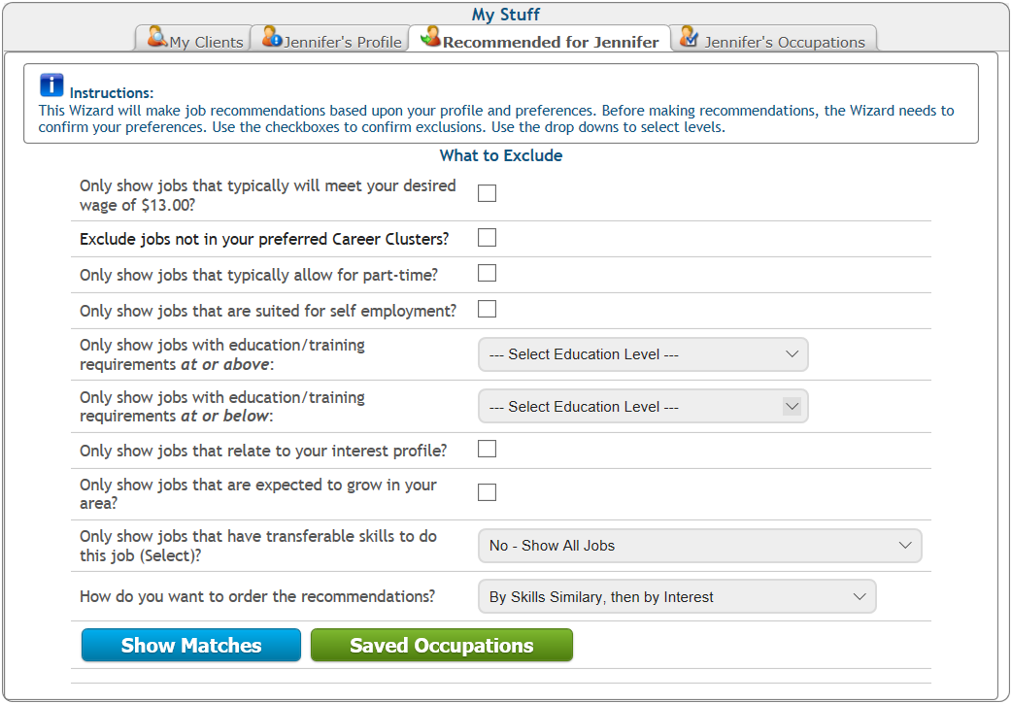
After clicking Show Matches, a Recommended Occupations table will load at the bottom of the screen. If no entries appear, try adjusting the number and/or type of exclusions.
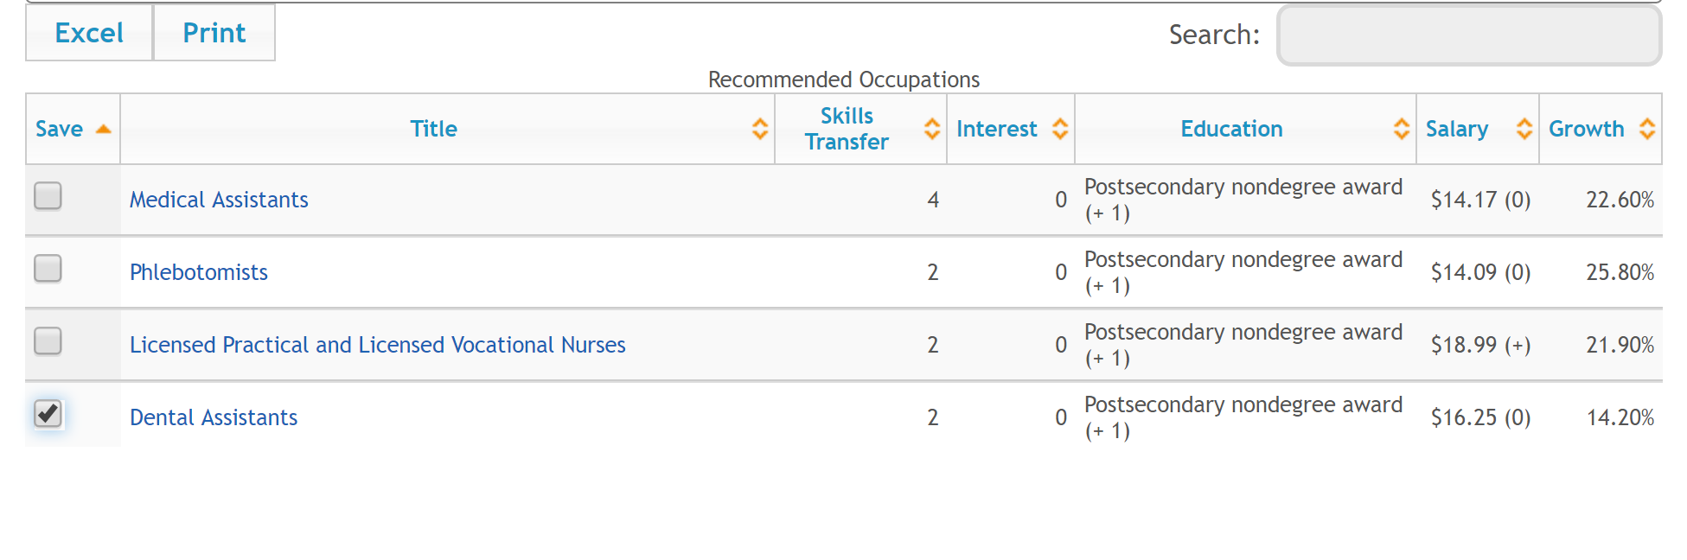
The Recommended Occupations table content can be sorted by column heading. It can also be searched using the Search field at the top right corner of the table. Entering text into the Search field will limit the results to show only those that contain the search text.
Underneath the table, users adjust the number of entries to show, and navigate through multiple pages (if applicable). Buttons above the Save column allow users to export the information to Microsoft Excel, or print the information.
The Excel and Print buttons easily capture client activity for
one-on-one discussion and coaching, documentation, integrated resource team use, supervisor meetings, and more.

The Recommended Occupations table contains the following information.
Item | Description
Save | Checking this box saves the occupation to the Occupations tab.
Title | Clicking on a title provides a brief description of the occupation. Click Ok to return to the Recommended Occupations table.
Skills Transfer | The skills transfer is measured on a scale of 0-5, with 0 being “No significant skills in common” and 5 being “Strong.”
Interest | Interest is measured on a scale of 0-5, with 0 being “No similarities” and 5 being “Perfect match.”
Education | Shows the typical required education level, and how many levels this is above (+) or below (-) the user’s recorded level of education.
Salary | A (+) after the salary level indicates the occupation typically provides a higher salary than the client’s requirements; a (0) after the salary level indicates the occupation typically provides the salary range the client desires; and a (-) after the salary level indicates the occupation does not typically provide the salary desired by the client.
Growth | Anticipated 10-year growth in the user’s local area.

Saved Occupations
The Occupations tab provides a list of previously saved occupations. Clicking on an occupation provides detailed information about the occupation.

Adding an Occupation
To add an occupation that is not currently listed, click the Add Occupation button (blue), and follow the on-screen instructions.

Comparing Saved Occupations
To compare occupations:
- Uncheck the box next to any occupations you do not wish to compare.
- Click Compare Occupations.
Comparison information will load below the Compare Occupations button. (You may need to scroll down to access it.) This information includes the Default Report sections: Definition, Wage Comparison, Job Openings, Growth, Education and Experience, and Key Employment Factors. To print the Default Report, click the Print button (blue) within the Comparing Occupations section.

Creating a Customized Report
To create a customized report, click Customize this report. A menu of report sections and work attributes will appear. Sections with checked boxes will be included in the customized report. Specific attributes under the Abilities, Skills, Knowledge, Work Context, and Work Values categories can be selected for inclusion or exclusion in the customized report.
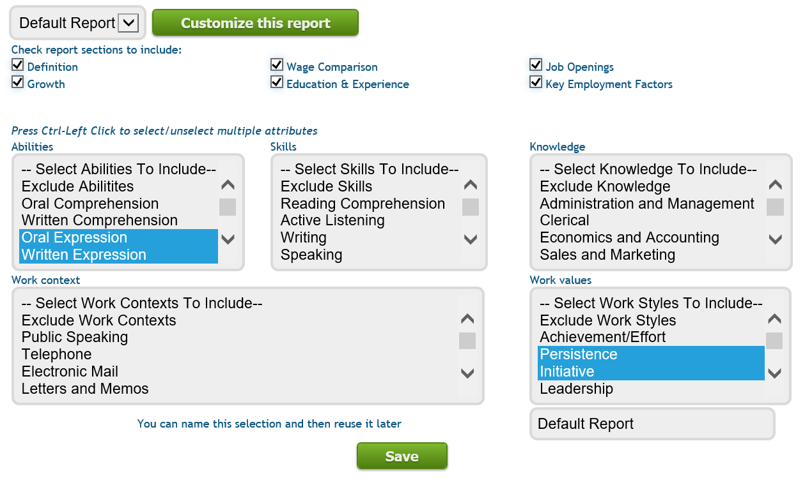
To create a customized report:
- Uncheck the box next to any report sections you wish to exclude.
- (Optional) Select the attributes to include or exclude. To select/deselect multiple attributes, hold down the CTRL key.
- Name the report (below the Work values section).
- Click Save.
Clicking Save produces the report and also saves the report parameters (i.e., the sections and attributes you selected) for future use. The drop-down menu to the left of the Customize this report button contains all previously saved reports.
When naming a customized report, use a name related to the attributes you selected. For example, if saving a report that excludes occupations that require good depth perception, a name like “Depth Perception Excluded” can be useful with other clients with depth perception concerns. Running the “Depth Perception Excluded” report with a different client profile will produce the results for that client. Running the “Depth Perception Excluded” report with a different set of saved occupations will produce the information for the selected occupations.

Running a Saved Report
To run a saved report with a new or different set of saved occupations:
- Return to the top of the Occupations screen.
- Uncheck the box next to any occupations you do not wish to compare.
- Click Compare Occupations.
- In the drop-down menu next to Customize this report, select the title of the report you wish to access.
The customized report will appear below the Customize this report button. (You may have to scroll down to access it.) To print the customized report, click the Print button (blue) within the Comparing Occupations section.

Viewing & Updating a My Stuff Profile
Maintaining a complete, accurate, and up-to-date My Stuff profile will produce the most relevant recommendations and Fit information. The My Stuff ( ) button at the top right corner of every screen within The Career Index Plus can be used to create, access, edit, and print a client’s profile. When a profile is changed, the information under the Recommended and Fit tabs automatically updates according to the new profile.

Searching for Labor Market Information
The Career Index Plus contains all the information a client needs to make an informed career choice. There are three ways to search for information using The Career Index Plus.

Search Types
Searching for an occupation is the most common type of search during the career exploration, planning, and goal-setting process (see Searching for an Occupation on page 52). Depending on where they are in the exploration process, clients may also conduct a Just Job Postings search (see Just Job Postings Search Information on page 89). Search results will display the most relevant data and information if the client has an accurate, complete, and up-to-date My Stuff profile (see Creating a My Stuff Profile on page 35).

Job Search Terms and Tips
Most searches within The Career Index Plus include a keyword(s) and a location.

Keyword(s)
In the Keyword(s) field, any word or combination of words related to an occupation can be entered, including military designations. Keywords can include any combination of the following types of searches.

If the search term includes… | …as in… | …the results screen will display…
A single word | Medical | Entries that include the word “Medical”
Multiple words separated by a space | Medical Assistant | Entries that include the word “Medical” or the word “Assistant”
Multiple words in quotation marks | “Medical Assistant” | Entries that include the term “Medical Assistant”
Multiple words separated by the word AND | Medical AND Assistant | Entries that include both the words “Medical” and “Assistant”
Multiple words separated by the word OR | Medical OR Assistant | Entries that include the word “Medical” or the word “Assistant”
Multiple words separated by the word NOT | Medical NOT Assistant | Entries that include the word “Medical” but not the word “Assistant”

Search terms can be combined to further refine a search. For example, entering “Medical Assistant” NOT Instructor will eliminate all results for “Medical Assistant” that contain the word “Instructor.”
All keyword searches relate back to an O*NET title, the key to a host of critical information. O*NET titles are like job families, rather than specific job titles. Therefore, a single O*NET title can cover many different job titles with similar attributes.
Whereas there are more than 300,000 job titles being used in the labor market today, there are only around 1100 O*NET titles. Job titles such as Bridge/Structure Inspection Team Leader, Railroad Design Consultant, and Traffic Engineer, for example, would all fall under the O*NET title of Civil Engineers.
Of over 300,000 job titles used in the labor market, only about 70,000 are used in The Career Index Plus. If you cannot find the title you want, try a different search term. Some titles may not have a specific O*NET title, but would be under the O*NET category of “All Other.” Because the jobs included in this classification are so broad, there are little data available for these, other than job openings, salary information, and projections.

Location
In the location field, any United States city-state combination or ZIP code can be used. The Career Index Plus provides, where available, local level data, data from the closest metropolitan statistical area, state level data, and national level data.
Job searches default to within 25 miles of the specified location. To further expand the search radius, see Jobs on page 62.

Searching for an Occupation
Searching for an occupation can be done with or without a My Stuff profile. If working side-by-side with a client, it is best to search from within the client’s account. Search results will be most relevant if the client has an accurate, complete, and up-to-date My Stuff profile (see Creating a My Stuff Profile on page 35). With a complete profile, the Occupation Information includes an additional tab, called Fit, which shows how the occupation fits the client’s My Stuff profile (see Occupation Information on page 53).
Follow the steps below to search for an occupation.
- Log in at www.thecareerindex.com.
- Enter a Keyword(s) and Location (ZIP code or city-state combination).
- Click Search.
The results screen will display a list of related occupations, with the closest match listed first, and the farthest match listed last.
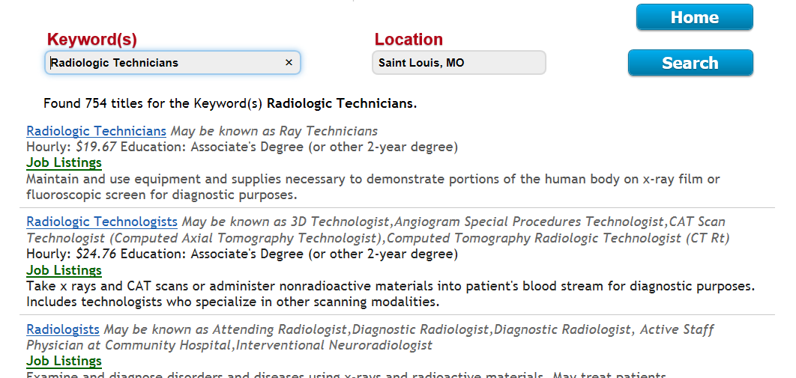

Clicking on a job title (blue) will provide detailed information about the occupation. Clicking on Job Listings (green) will provide a list of job openings in the specified location.

Occupation Information
From many screens within The Career Index Plus, clicking on a job title opens the Occupation Information screen. This may include the Overview, Fit, Related Jobs, Viability, Suitability, Training, and Print tabs. If specific sections were excluded under the Account button, the excluded sections will not appear (see Configuring What Information is Displayed on page 30). If the selected occupation is in an “All Other” category, only job openings, salary information, and projections are available.

Overview
The Overview tab displays information from the Occupational Outlook Handbook provided by the U.S. Department of Labor’s Bureau of Labor Statistics. This includes the following, where available:
- Title and job family
- Description
- With some titles, a 3- to 4-minute captioned career video
- Typical qualifications
- Work environment
- Work schedules
- National and state job outlook
- Number of local and state job postings (based on the specified location)
- Typical salary within the closest metropolitan statistical area
- Entry-level education requirements
- Typical required experience
- How to become one (additional information about education and training)
- Important qualities/skills
- Licenses, certifications, and registrations
- Links for more information
At the bottom of the screen, checking the box next to Save this occupation saves the occupation under My Stuff > Occupations (see Saved Occupations on page 46).

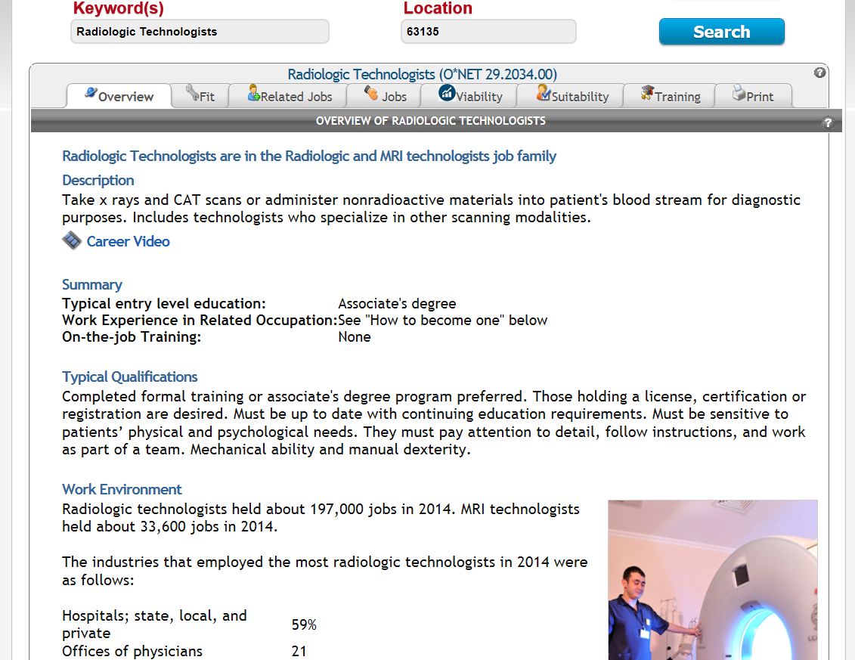

When considering the information in the Overview tab, some possible considerations may be:
  - Does this interest me?
  - Does this sound like something I could do?
  - At first glance, does it seem to meet my financial requirements?

Fit
The Fit tab provides an analysis of the occupation based on the user’s profile. It compiles the available information from the other tabs, including Related Jobs, Jobs, Viability, Suitability, and Training, and indicates strengths and potential challenges based on the My Stuff profile.
At the bottom of the Fit screen, the user can save the occupation and/or record a comment for future reference.
From a counselor account, if a My Stuff profile is being used, the client’s name will appear at the top of the Fit screen, along with the occupation title that was selected.
The Fit analysis includes the following viability-related information.
Item | Description
General | General information relating to the Basics tab that the client completed during profile creation (e.g., whether the occupation is suitable for full time or part time work).
Salary Analysis | Salary range for the occupation specific to entered location, current, average salary for the area, and whether or not the occupation meets the client’s desired wage.
Experience Analysis | How much experience employers require, and whether or not the user’s work experience includes transferable skills; what knowledge and skills the user might need to acquire for the occupation and what knowledge and skills the user might already have based on previous work experience.
Job Trends | Projected state growth and number of local and state job openings.

If a client entered Social Security Income (SSI) and/or Social Security Disability Insurance (SSDI) values in the Basics tab during account creation, the Fit tab will estimate the total amount of income from benefits and the total amount of income from a job in the selected occupation over time, and compare the two.
The Fit analysis includes the following suitability-related information.
Item | Description
Potential Work Environment Issues | Compares the selections made under the Work Context tab, to the typical requirements for the selected occupation.
Education Analysis | Whether the user’s education level is appropriate for the occupation.
Interest Profile Analysis | Whether the chosen occupation fits with the user’s interest profile.
Top Work Styles Comparison | Compares the Work Styles from the job title the user selected as his or her “favorite” under the Work History tab, to the Work Styles for the selected occupation.
Top Work Values Comparison | Compares the Work Values from the job title the user selected as his or her “favorite” under the Work History tab to the Work Values for the selected occupation.

When considering the information in the Fit tab, some possible considerations may be the following:
  - How does this occupation compare to my profile?
  - With the strengths and potential challenges, is this still something that holds my interest? Is this something I could do?
  - How can I build upon my strengths to become the ideal candidate for this occupation?
  - What can I do to address the potential challenges?
If certain requirements, preferences, or labor market conditions make the selected occupation “unfit” for your client, the Related Jobs tab can be used to explore similar occupations that might be a better fit (see Related Jobs below).
The Fit tab can focus counseling conversations on how to build upon strengths, and how to address potential challenges. This can change the counselor’s role to career coach and mentor versus bearer of bad news.

Related Jobs
The Related Jobs tab provides a list of occupations that are related or similar to the selected occupation. Occupations may be related by title, skill, interest, career pathways, or common transitions.
When considering the information in the Related Jobs tab, some possible considerations may be:
  - What other job titles might hold my interest?
  - In what other jobs might my skills be useful?
  - What could be my career pathway in this field?
  - What type of advancement opportunity does this occupation have?
  - How can I get my foot in the door for this type of occupation?
  - What other jobs do people with this job go to and come from?
  - If this is not the occupation for me, what might be some other options?

Also Known As
The Also Known As sub-tab lists alternate titles for the selected occupation.

Related By Skill
The Related By Skill sub-tab lists occupations that require a similar skill set, in order from most to least similar.

Within the Related By Skill, Related By Interest, Career Pathways, and Transitions sub-tabs in this section:
- The currently selected title, typical wage, and education level appears at the top of the screen.
- The typical wage and education level is listed to the right of each title.
- An item with a down arrow (which also appears in red) means the typical wage or education is lower than the currently selected title.
- Clicking a title provides the Occupation Information for that title.
- To save an occupation to My Stuff > Occupations, check the box under the Save column to the left of the title (see Saved Occupations on page 46).

Related By Interest
The Related By Interest sub-tab lists occupations with a similar Holland Interest Code (see Interest Profile on page 38). The Holland Interest Code appears next to each title on this screen.
Within the Related By Skill, Related By Interest, Career Pathways, and Transitions sub-tabs in this section:
- The currently selected title, typical wage, and education level appears at the top of the screen.
- The typical wage and education level is listed to the right of each title.
- An item with a down arrow (which also appears in red) means the typical wage or education is lower than the currently selected title.
- Clicking a title provides the Occupation Information for that title.
- To save an occupation to My Stuff > Occupations, check the box under the Save column to the left of the title (see Saved Occupations on page 46).

Career Pathways
The Career Pathways sub-tab lists occupations that are within the same Career Pathway (or “ladder”) of the selected occupation. Results appear from lowest to highest levels of the career pathway. Clients can move up (with occupations at the bottom of the screen) or down (with occupations at the top of the screen) through the ladder based on education and experience.
Within the Related By Skill, Related By Interest, Career Pathways, and Transitions sub-tabs in this section:
- The currently selected title, typical wage, and education level appears at the top of the screen.
- The typical wage and education level is listed to the right of each title.
- An item with a down arrow (which also appears in red) means the typical wage or education is lower than the currently selected title.
- Clicking a title provides the Occupation Information for that title.
- To save an occupation to My Stuff > Occupations, check the box under the Save column to the left of the title (see Saved Occupations on page 46).

Transitions
The Transitions sub-tab lists occupations that individuals in the selected occupation typically come from (transition from) or go to (transition to).
Within the Related By Skill, Related By Interest, Career Pathways, and Transitions sub-tabs in this section:
- The currently selected title, typical wage, and education level appears at the top of the screen.
- The typical wage and education level is listed to the right of each title.
- An item with a down arrow (which also appears in red) means the typical wage or education is lower than the currently selected title.
- Clicking a title provides the Occupation Information for that title.
- To save an occupation to My Stuff > Occupations, check the box under the Save column to the left of the title (see Saved Occupations on page 46).

Jobs
The Jobs tab displays job listings along with a brief description of each, the location of the job, company/employer information, and the date that the listing was posted.
If there are multiple pages of results, users can navigate through the pages using the page numbers below the search area and above the job listings.
Under the Job column, clicking a job title will open the job ad in a new window, where the user can view, save, or apply to the ad.
Under the Company column, clicking the Web link will open a Google search of the company. Clicking the Map link will open an interactive Google Map of the company. Clicking the News link will open a Google search for related news.
The search area at the top of the screen can be used to modify the search.
- Complete and/or modify the relevant fields.
- Click Search.
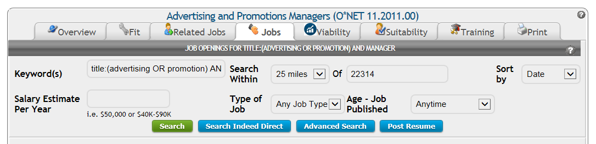

Search options are described in the following table.
Field Title | Description | Options | Default Setting
Keyword(s) | Search terms | See Job Search Terms and Tips on page 50 | Searches for the previously selected occupation
Search Within | Specifies the search radius | “Only in” the specified area, or within 5, 10, 15, 25, 50, or 100 miles | 25 miles
Of | Specifies the city-state combination or ZIP code of the previously specified location | Can enter any city-state combination or ZIP code | The most recently entered location
Sort by | Specifies how the user would like the results to be displayed | Date (most to least recent), Job Title, Location, or Company | Most to least recent
Salary Estimate Per Year | Specifies the client’s desired annual salary or range | Any number/range may be entered (e.g., $50,000 or $40K-$90K), or the field may be left blank | Blank (all salaries)
Type of Job | Specifies the client’s desired job type | Any Job Type, Full time, Part time, Contract, Internship, or Temporary | Any Job Type
Age - Job Published | Specifies how long ago the job ad was posted by the employer | Any time, Within the last 15, 7, or 3 days, Since Yesterday, or Since Last Visit | Any time

When considering the information in the Jobs tab, some possible considerations may be:
  - Are there current job openings in this location? If not, where are they?
  - Would a longer commute or relocation be necessary? Is that feasible?
  - If I depend on public or other transportation, could I get to these jobs reasonably and reliably?
  - What companies or types of companies are hiring for this occupation?
  - What are these companies looking for in a candidate?
  - Do these seem like employers I would want to work for?
  - How can I connect with former or present employees to set up informational interviews and other networking opportunities?
  - How can I tailor my resume to specific job ads?
  - Is there any training, education, or professional development I would need in order to be a better candidate for these openings?
If you are not seeing any jobs within the current Search Within setting, try increasing the search radius. If you still are not finding many jobs, check the Viability tab. If the Wages and Job Trends data suggest that the position is still viable, the Industries sub-tab can be used to identify employers to contact regarding the “hidden job market.” Some employers may have job openings that are not posted online, or may be willing to create positions for a promising candidate.

Searching Indeed® Directly
The Indeed® website contains additional filters, along with an option to receive email alerts when new jobs matching the search criteria are posted. To use these features, click on the Search Indeed Direct button below the search options. This opens a new window with the search results in Indeed®. A direct search in Indeed® may also help find highly specialized positions (e.g., “Board Certified Behavior Analyst”) that do not fall neatly under a specific O*NET title.

Conducting an Advanced Search
For additional search options, or to further refine a search, click on the Advanced Search button. This opens the Indeed® Advanced Job Search page in a new window. An Advanced Search is particularly helpful when there are several search results that are not relevant to the client.

Building and Posting a Resume
Once they have had a chance to review job ads, users can click Post Resume to upload or build a resume on the Indeed® website.

Viability
The Viability tab contains labor market information about wages, job trends, and industries.
This information can be used to determine if an occupation is economically viable given the client’s wage requirements.
When considering the information in the Viability tab, some possible considerations may be:
  - What is the earning potential, and does it fit within my desired wage?
  - When I am ready to get hired, are there likely to be enough companies that are hiring?
  - Once I get a job in this occupation, is the job likely to stick around a while?
  - Is there a lot of competition for jobs in this occupation?
  - Am I likely to find a lot of job postings?
  - If I am willing/able to relocate, or if I want to speak with someone in this occupation, where am I most likely to find other people in this occupation?
  - In what industries do people in this occupation work? Am I interested in any of these?
  - What are some potential employers in my desired location? Do these seem like employers for whom I want to work?
  - How can I connect with potential employers to set up informational interviews or networking opportunities?

Wages
The Wages sub-tab contains median salary information for the selected occupation.
To help determine if an occupation is economically viable for a client, compare the Wages information with the client’s desired salary range.
Category/Description | What percent of employees earn less? | What percent of employees earn more?
Low | 10% | 90%
Median | 50% | 50%
High | 90% | 10%
The bar graph at the top of the Wages sub-tab provides Occupational Employment Statistics (OES) data from the U.S. Department of Labor’s Bureau of Labor Statistics (BLS). Median salary data are based on an annual survey that asks what the respondents earned during the three-year period prior to the survey. Salary data are separated into three categories.

The first bar in each section (which appears green) represents data from the closest metropolitan statistical area, while the second bar in each section (which appears blue) represents state-level data. Next to each bar, the letter A represents the annual salary. Hourly rates are provided next to the annual salary.

Job Trends
The Job Trends sub-tab provides local, state, and national labor market trends from the U.S. Department of Labor and state Labor Market Information (LMI) divisions.
State projections include the State Job Outlook, the 10-year projected annual growth, number of job postings that need to be filled within the 10-year period, total workers in the occupation, and annual job openings.
Data from the closest metropolitan statistical area include the number of total workers in the area, the number of workers in the selected occupation, and the projected number of job postings that need to be filled within the 10-year period.
National projections data include the 10-year projected national growth, the National Job Outlook, and the area(s) with the highest concentration of workers in the selected occupation. (Date ranges for the 10-year projections may vary.)
Where rankings are provided, the figure is compared to all other occupations in the area. For example, “Ranks top 9% in state” next to Annual Growth means that the occupation is growing annually more than 81% of all other occupations in the state.

Industries
The Industries sub-tab lists the top industries (in order) for the selected occupation, along with a link to potential employers, the percent of workers in the occupation who work in the industry, the number of workers in the industry nationally, and the projected 10-year growth for the industry.
Clicking the industry name provides a list of the top 15 job titles found in the industry. Clicking the Potential Employers button opens an interactive Google Map in a new window. Click the Google search icon () for potential employers in the local area.
Do you have a client who is thinking about self-employment? The Industries tab may contain information about the number and projected growth of workers who are self-employed.
Use the Industries tab to help identify potential employers who do not usually post job openings online. An estimated 80% of all job openings are not posted online. For some occupations, such as cashiers, retail clerks, sales representatives, and short order cooks, employers may only use “now hiring” signs in their local area.
The Potential Employers button can be used to search “the hidden job market” for potential employers, information, and contacts that could turn into networking opportunities and/or job leads.

Suitability
The Suitability tab allows a client to evaluate an occupation in terms of his or her strengths, training and/or education, resources, priorities, concerns, abilities, capabilities, and interests.
Suitability data come from the O*NET Online database, which is based on surveys of occupation incumbents and employers.
When considering the information in the Suitability tab, some possible considerations may be:
  - Does this sound like work I can do?
  - Does this interest me?
  - Are there any deal breakers here?
  - What are my strengths, and how can I use them to position myself as a good candidate?
  - Are there any potential challenges? If so, how can I address them?
  - Are there areas where I would need to request an accommodation, or where assistive technology would be helpful?

Interests
The Interests sub-tab displays the selected occupation’s Holland Interest Profile.
The Holland Profiles consists of six interest areas: Realistic (Doer), Investigative (Thinker), Artistic (Creator), Social (Helper), Enterprising (Persuader), and Conventional (Organizer). For a more detailed description of the Holland Profile, see Interest Profile, Page 38.

Work Context
The Work Context sub-tab contains physical and social factors that influence the nature of work. This includes elements related to interpersonal relationships, physical work conditions, and structural job characteristics.
Under Description, hover over an item for the O*NET survey question related to the item. The Most Common Answer is provided next to each item.
This screen provides a wealth of information to discuss with clients and potential employers when exploring options for customized and/or competitive integrated employment.

Tasks
The Tasks sub-tab contains core and supplemental tasks for the selected occupation, along with the most common frequency, relevance to the occupation, and importance of each task.
Next to each task, the Relevance to Occ column (with green bars) shows the percentage of employers who rated the task as relevant to the job. The Importance column (with orange bars) shows task importance on a scale from 1 to 100 (see table below).
Table 1: Importance Ratings
Rating | Importance
0-20 | Not important
21-40 | Somewhat important
41-60 | Important
61-80 | Very important
81-100 | Extremely important

When reviewing this information, make sure the client understands what is involved in each task, and explore whether additional training, education, experience, or accommodations may be necessary.

Activities
The Activities sub-tab contains a Description of work activities, along with level of complexity/difficulty, and importance for each.
Next to each activity, the Level column (with green bars) shows the level of complexity on a scale of 1 to 100. The Importance column (with orange bars) shows activity importance on a scale from 1 to 100 (see Table 1: Importance Ratings, on page 73).
Activities are listed in order of importance, and may be sorted differently by column heading. To view activities with an importance score below 40, click Show All Activities at the top of the Description column.
Click on the information button ( ) for an activity’s definition and additional information about the complexity levels and importance scales. (Click on the button again to hide this information.)
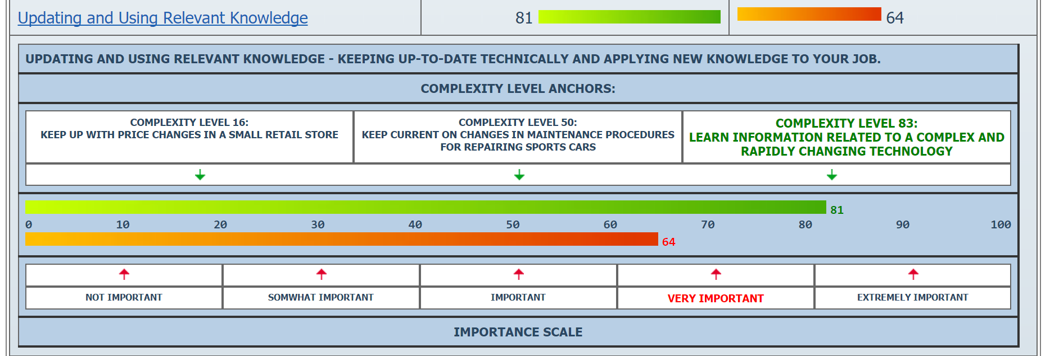
When reviewing this information, make sure the client understands what is involved in each activity, and explore whether additional training, education, experience, or accommodations may be necessary.

Abilities
The Abilities sub-tab contains enduring attributes of the client that influence performance.
There are four O*NET categories of abilities, described in the following table.
Category | Description
Cognitive | Abilities that influence the acquisition and application of knowledge in problem solving
Physical | Abilities that influence strength, endurance, flexibility, balance and coordination
Psychomotor | Abilities that influence the capacity to manipulate and control objects
Sensory | Abilities that influence visual, auditory and speech perception
Next to each ability, the Level column (with green bars) shows the level of complexity on a scale of 1 to 100. The Importance column (with orange bars) shows ability importance on a scale from 1 to 100 (see Table 1: Importance Ratings on page 73).
Abilities are listed in order of importance, and may be sorted differently by column heading. To view abilities with an importance score below 40, click Show All at the top of the Description column.
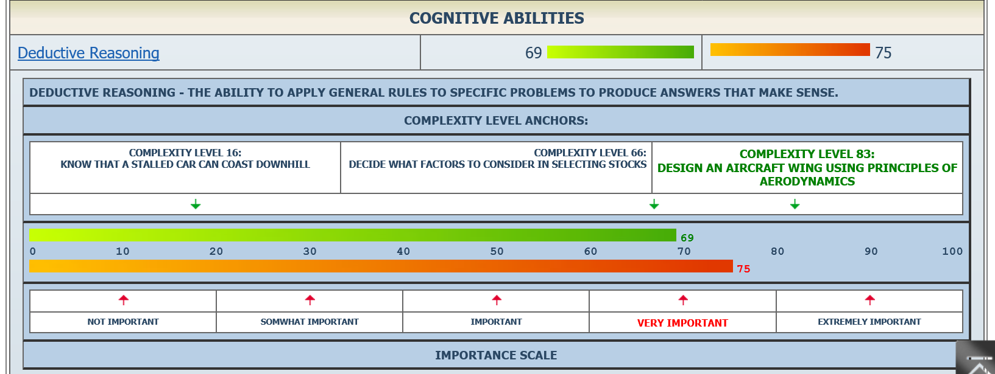
Click on the information button ( ) for an ability’s definition and additional information about the complexity levels and importance scales. (Click on the button again to hide this information.)

Knowledge
The Knowledge sub-tab describes the type of knowledge required for the occupation.
Next to each type of knowledge, the Level column (with green bars) shows the level of complexity on a scale of 1 to 100. The Importance column (with orange bars) shows knowledge type importance on a scale from 1 to 100 (see Table 1: Importance Ratings on page 73).
Knowledge types are listed in order of importance, and may be sorted differently by column heading. To view items with an importance score below 40, click Show All at the top of the Description column.
Click on the information button ( ) for a knowledge type’s definition and additional information about the complexity levels and importance scales. (Click on the button again to hide this information.)
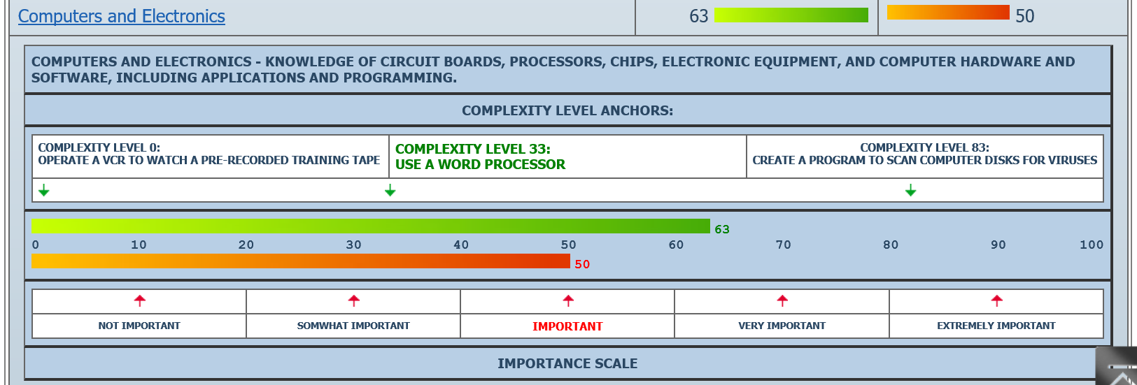

This information is useful when discussing education, training, and experience that relates to a particular occupation.

Skills
The Skills sub-tab contains required skills for the occupation.
Next to each skill, the Level column (with green bars) shows the level of complexity on a scale of 1 to 100. The Importance column (with orange bars) shows skill importance on a scale from 1 to 100 (see Table 1: Importance Ratings on page 73).
Click on the information button ( ) for a skill’s definition and associated levels of complexity. Skills are listed in order of importance, and may be sorted differently by column heading. To view skills with an importance score below 40, click Show All at the top of the Description column.
Even if a client lacks direct experience in a related position, he or she may have transferrable skills. Developing short stories that outline the Situation, Challenge(s), Action(s), and Result(s) of a specific experience can help highlight the skills that could be transferred over from one position to another.

Styles
The Styles sub-tab contains personal characteristics that can affect how well someone performs a job.
Hover over a work style for a definition of the item. The Importance column (with orange bars) shows work style importance on a scale from 1 to 100 (see Table 1: Importance Ratings on page 73).
Developing short stories that outline the Situation, Challenge(s), Action(s), and Result(s) of a specific experience can help highlight valuable work styles. Discussions around these stories can also help in identifying personal/professional goals, and opportunities for growth.

Values
The Values sub-tab contains global aspects of work that are important to a person’s satisfaction.
Hover over a value for a definition of the item. The Level column (with orange bars) shows how much the value affects the nature of the job on a scale from 1 to 100 (see Table 1: Importance Ratings on page 73).
Even though these values apply to the occupation in general, some employers may have a culture that favors certain values over others. Informational interviews with current or past employees can help identify a good match between employer culture and candidate values.

Tools
The Tools sub-tab lists the tools and technology (with examples) typically used on the job.

Training
The Training tab contains information about Schools, Licenses and Certifications, Related Training, and Experience/Education related to the selected occupation.
When considering the information in the Training tab, some possible considerations may be:
  - What type of experience and education/training is typically required for this occupation?
  - What type of license or certification would I need for this occupation? What is the process? Do I think I can do this? Would these requirements disqualify me for any reason?
  - If I need additional training/education, where would I find relevant training programs and schools?

Schools
The Schools sub-tab contains a list and interactive Google Map of schools that offer training relevant to the selected occupation, offer student loans and grants, and are located within 40 miles of the specified location.
If no schools are found within 40 miles, the 10 closest schools are displayed. Clicking More Schools expands the search area. Clicking Less Schools reduces the search area. The Career Index Plus contains detailed information about more than 200,000 training programs.
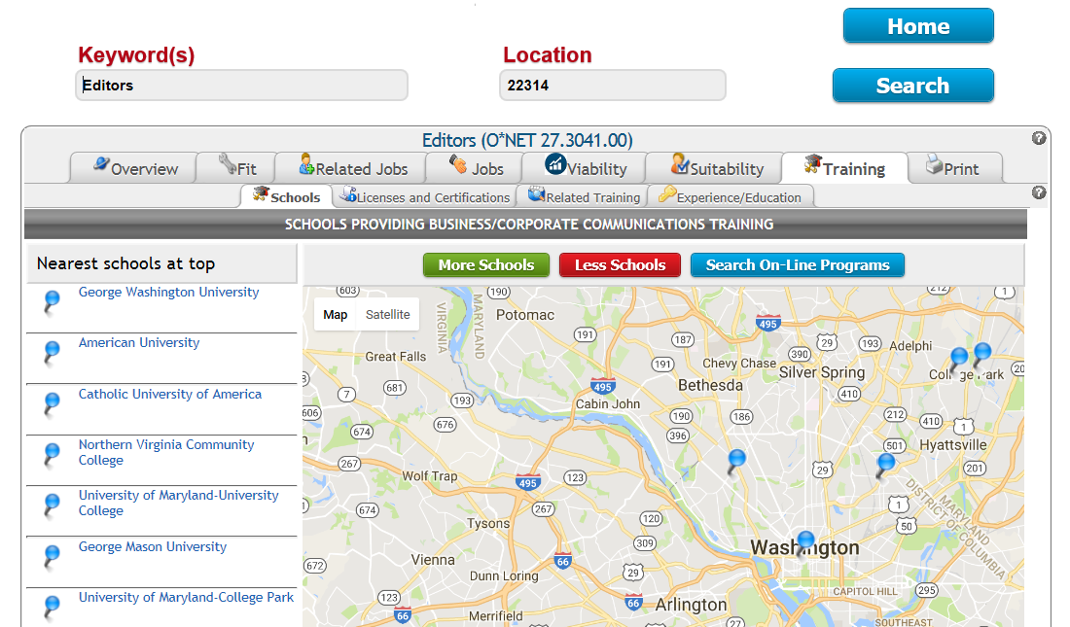

Clicking on a school name pinpoints the location on the map and displays links to detailed school information.
- The Program Info link contains information about the school’s related training programs. From there, clicking the Research This Program link opens a Google Search on the program for that school. The School Website link opens the school’s website.
- The School Info link provides detailed school information from the Institute of Education Sciences (IES), National Center for Education Statistics (NCES), College Navigator site.
- The Street View link shows the Google Map Street View.
- The website link below the address and telephone number opens the school’s website in a new tab or browser window.
Browsing the school’s website can give someone an idea of whether they are interested in a particular program. Close the browser window to get back to the The Career Index Plus website after browsing.

Licenses and Certifications
The Licenses and Certifications sub-tab contains information about state licenses (first) and national certifications (next) related to the occupation.
The screen will alert the user if no licenses and/or certifications have been identified for the selected occupation or state. License/certification information includes the type (core or specialty), name, licensing/certification authority and website, and a link (URL) to related job openings. Clicking the license/certification name provides additional information about the license or certification.
If a license or certification is required, contacting the licensing/certification authority directly can provide information and guidance, such as whether a criminal background check is required, what level of education is required, etc.

Related Training
The Related Training sub-tab contains the Title and Description of training programs related to the selected occupation.
Clicking on a title provides the Occupation Information for that title.

Experience/Education
The Experience/Education sub-tab contains information about the amount of experience and education typically required for the occupation.
This screen displays up to six categories of education and experience that employers are looking for in potential candidates for the selected occupation. These categories are described below.
The Preparation Level information is based on O*NET Job Zones. A Job Zone is a group of occupations that are similar in how much education, related experience, and on-the-job training people need to do the work. There are five Job Zones. The higher the Job Zone, the more preparation is needed (see table below).
Table 2: Job Zones
Job Zone | Amount of Preparation Needed
1 | Little or none
2 | Some
3 | Medium
4 | Considerable
5 | Extensive
The Typical Qualifications information is based on employer job ads.
The Most Common Related Work Experience section includes Bureau of Labor Statistics (BLS) employer survey results and indicates if work experience in a related occupation is commonly considered necessary by employers for entry into the occupation, or is a commonly accepted substitute for formal types of training.
The Typical Required Education Level section includes BLS employer survey results and represents the typical education level most workers need to enter an occupation.
The Most Common On-Site or In-Plant Training section includes BLS employer survey results and indicates the typical on-site or in-plant training needed to attain competency in the skills needed in the occupation.
The Most Common On-The-Job Training section includes BLS employer survey results and indicates the typical on-the-job training needed to attain competency in the skills needed in the occupation.

Printing, Emailing, or Saving a Report
The Print tab displays options for creating a customized report for the desired occupation.
Checking the box next to an item includes that section in the report. A Check/Uncheck All box is included for convenience. The Career Index Plus will “remember” your selections, so the next time you print a report, the items you selected previously will be included by default.
Adobe Reader is required for viewing, downloading, and printing a report. If the computer does not have Adobe Reader, a download prompt will appear.
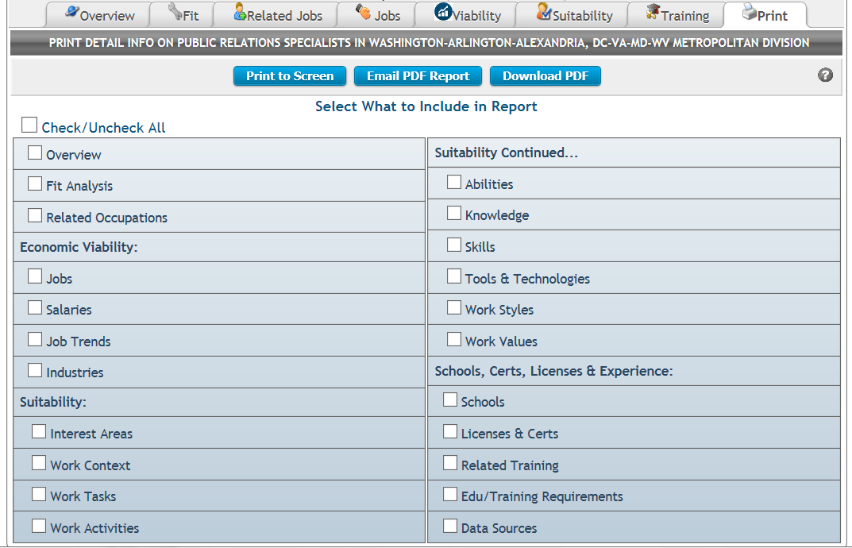

Viewing and Printing a Report
After selecting what to include in a report, clicking the Print to Screen button opens the selected sections in a single screen (so the user can scroll down, rather than using tabs, to view each section). Clicking the Print button at the top right corner of the report opens the browser’s print dialogue box.

Individuals who use a screen reader, such as JAWS®, will find content headings at the top of the screen. At the bottom of each section, a Back to Top link jumps back to the content headings at the top of the screen.
The Print to Screen button is useful if you need to manually copy and paste information into another document such as an Individualized Plan for Employment (IPE), or into another program such as a Case Management System (CMS).

Emailing a Report
After selecting what to include in a report, clicking the Email PDF Report button allows the user to automatically email the report to another individual or individuals.
- Enter the name and email address of the intended recipient (one only).
- (Optional) In the CC field, enter your email address if you would like a copy of the email/report. Or, if the client has provided informed consent to copy someone else on the email/report, enter that email address here. Only one email address may be entered in this field, or it may be left blank.
- (Optional) If desired, modify the Subject line.
- (Optional) Next to Add Email Text, enter a message to the recipient.
- Click Send Email.
The email will be sent as if from the user’s email address, with the report as an Adobe PDF attachment. The screen will provide confirmation when the email/report has been sent.

Both Clients and Counselors can use this feature to share information. Counselors can use this feature to send a report to a client, designated family member, or other authorized workforce partner, and clients can use this feature to send a report to a counselor.

Downloading and Opening a Report
After selecting what to include in a report, clicking the Download PDF button allows the user to download and open the Adobe PDF report.
- The screen will say Document generation complete! when the download is complete.
- If the PDF file is not on screen, and no other on-screen instructions or dialogue boxes pop up, check the computer’s Downloads folder.
- Open the file using an Adobe PDF reader.
Once the file is open, the user can view the report, copy and paste information from the report to another document or program, download the report, or print the report.

Just Job Postings Search Information
If an individual has already been through the assessment, planning, and goal-setting process, has identified a career path, and is ready to search for jobs, the fastest way to do so is through the Just Job Postings feature.

Conducting a Just Job Postings Search
Follow the steps below to conduct a Just Job Postings search.
- From the Home screen, click Just Job Postings.
- Enter a keyword(s).
- Next to the word Of, enter a city-state combination or ZIP code.
- (Optional) Complete the remaining fields as desired.
- Click Search.
Most searches within The Career Index Plus include a keyword(s) and location; for job postings, however, searches may leave out one or the other. Entering a keyword without a location will display all results nationwide. Entering a location without a keyword will display all jobs within the specified area.
If a client is willing/able to relocate, is looking for remote or work-from-home opportunities, or is looking for a job title with very few openings, enter a keyword(s) without a location. This will display all related jobs nationwide. To search for all jobs within a particular location, or to determine what types of jobs are available in the local labor market, enter a location without a keyword(s). This is particularly useful for clients seeking employment in rural areas or areas where few job openings are expected.

Just Job Postings Search Results
See Jobs, Page 61, for information about search results.

Additional Resources
The Career Index Plus includes additional information and resources for individuals with disabilities and ex-offenders.
- From the Home screen, click on Resource Links.
- At the top of the screen, select the Disability Resources or the
Ex-Offender Resources tab.
Links on these pages will open a Google search for the selected topic in a new browser window or tab. The views in the Resource Links do not necessarily reflect the views of The Career Index®. The Career Index does not curate, verify, or endorse any of the information provided in the external Resource Links.
To get back to the previous page, close the browser window or tab.

Disability Resources
Click on a subject for more information. For information on a specific disability, enter the disability and click Go.

Ex-Offender Resources
Click on a subject for more information.

