Quick Reference Card: Suitability

Suitability
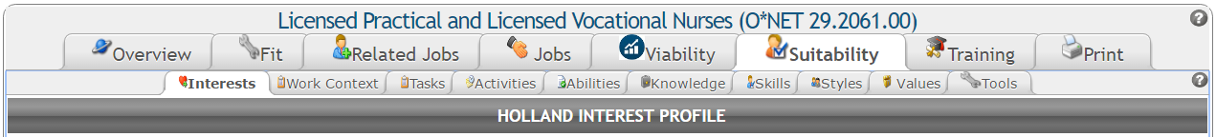
The Suitability tab allows you to evaluate an occupation in terms of a large number of occupational characteristics gleaned from the O*NET database. With each sub-tab, you can hone in on a specific area of interest to you.

Interests
The Interests sub-tab displays the occupation’s Holland Interest Profile, followed by lists of similar occupations with the same and similar interest profiles. The Holland Profiles consist of the following six interest areas: Realistic (Doer), Investigative (Thinker), Artistic (Creator), Social (Helper), Enterprising (Persuader), and Conventional (Organizer).

Work Context
The Work Context sub-tab contains a number of categorized factors that influence the nature of work. This includes elements related to interpersonal relationships, physical work conditions, and structural job characteristics. Under the Description column, hover over an item to see the O*NET survey question related to the item. The Most Common Answer is provided next to each item.

Tasks
The Tasks sub-tab contains core and supplemental tasks for the selected occupation, along with the most common frequency, relevance to the occupation, and importance of each task. Next to each task, the Relevant to Occ column (with green bars) shows the percentage of employers who rated the task as relevant to the job. The Importance column (with orange bars) shows task importance on a scale from 1 to 100 (see table below).
Table 1: Importance Ratings
Rating | Importance
0-20 | Not important
21-40 | Somewhat important
41-60 | Important
61-80 | Very important
81-100 | Extremely important

Activities
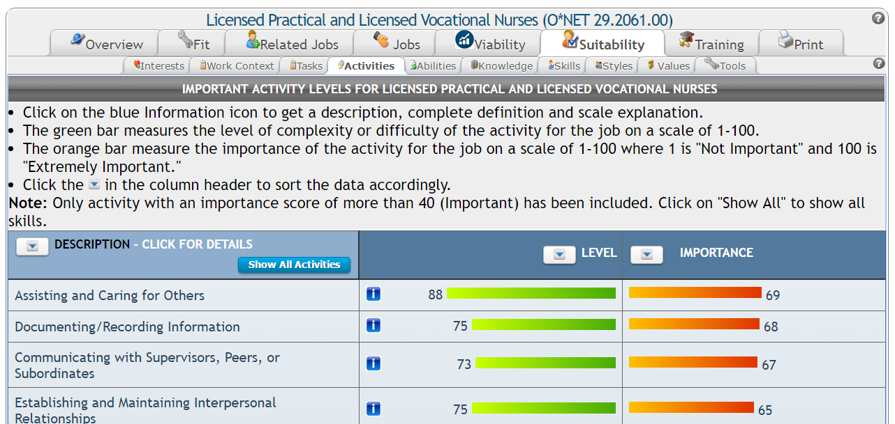
Note: The Activities, Abilities, Knowledge, and Skills tabs all work the same way.
The Activities sub-tab contains a Description of work activities, along with level of complexity/difficulty, and importance for each. Next to each activity, the Level column (with green bars) shows the level of complexity on a scale of 1 to 100. The Importance column (with orange bars) shows activity importance on a scale from 1 to 100 (see Table 1: Importance Ratings, on page 2). Activities are listed in order of importance, and may be sorted differently by column heading. To view activities with an importance score below 40, click Show All Activities at the top of the Description column.
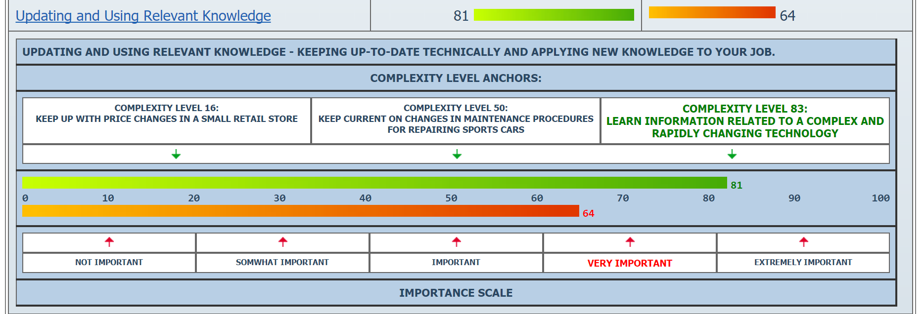
Click on the blue Information icon for its definition and additional information about the complexity levels and importance scales. Click on the blue information icon again to hide this information.

Abilities
The Abilities sub-tab contains enduring attributes of the individual that influence performance. There are four O*NET categories of abilities, which are described in the following table.
Category | Description
Cognitive | Abilities that influence the acquisition and application of knowledge in problem solving
Physical | Abilities that influence strength, endurance, flexibility, balance, and coordination
Psychomotor | Abilities that influence the capacity to manipulate and control objects
Sensory | Abilities that influence visual, auditory, and speech perception
Next to each ability, the Level column (with green bars) shows the level of complexity on a scale of 1 to 100. The Importance column (with orange bars) shows ability importance on a scale from 1 to 100 (see Table 1: Importance Ratings, above).
Abilities are listed in order of importance, and may be sorted differently by column heading. To view abilities with an importance score below 40, click Show All Abilities at the top of the Description column.

Knowledge
The Knowledge sub-tab describes the type of knowledge required for the occupation. Next to each type of knowledge, the Level column (with green bars) shows the level of complexity on a scale of 1 to 100. The Importance column (with orange bars) shows knowledge type importance on a scale from 1 to 100 (see Table 1: Importance Ratings, above).
Knowledge types are listed in order of importance, and may be sorted differently by column heading. To view items with an importance score below 40, click Show All Knowledge at the top of the Description column.

Skills
The Skills sub-tab contains required skills for the occupation. Next to each skill, the Level column (with green bars) shows the level of complexity on a scale of 1 to 100. The Importance column (with orange bars) shows skill importance on a scale from 1 to 100 (see Table 1: Importance Ratings, above). Skills are listed in order of importance, and may be sorted differently by column heading. To view skills with an importance score below 40, click Show All Skills at the top of the Description column.

Styles
The Styles sub-tab contains personal characteristics that can effect how well someone performs a job. Hover over a work style for a definition of the item. The Importance column (with orange bars) shows work style importance on a scale from 1 to 100 (see Table 1: Importance Ratings, above).

Values
The Values sub-tab contains global aspects of work that are important to a person’s satisfaction. Hover over a value for a definition of the item. The Level column (with orange bars) shows how much the value affects the nature of the job on a scale from 1 to 100 (see Table 1: Importance Ratings, above).

Tools
The Tools sub-tab lists the tools and technology (with examples) typically used on the job.

