Quick Reference Card: Related Jobs

Related Jobs
The Related Jobs tab provides a list of occupations that are related or similar to the selected job title. Occupations may be related by title, skill, interest, career pathways, or common transitions.
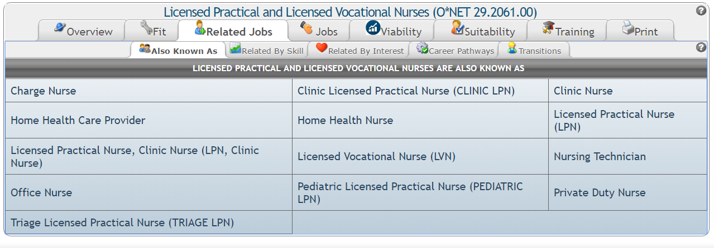
Within each sub-tab in the Related Jobs section, except for the Also Known As sub-tab, the following information is available:
- The local wage range and typical education level is listed to the right of each title.
- An item with a downward or upward arrow means the average salary or education required is lower (downward) or above (upward) the currently selected title.
- Clicking a title takes you to the detailed information on the selected title.
- To save an occupation to My Stuff > My Occupations, check the box to the left of the title, under the Save column. Note: The moment you click save, the title is saved. If you click it again, the title will be un-saved.

Also Known As
The Also Known As sub-tab lists alternate titles for the selected title.

Related By Skill
The Related By Skill sub-tab lists occupations that require a similar skill set, in order from most to least similar.

Related By Interest
The Related By Interest sub-tab lists occupations with a similar Holland Profile. The Holland Profile appears next to each title on this screen. It is a 1- to 3-character code that may consist of any combination of characters from the following table.
Character | Category | Occupations Frequently Involve
R | Realistic (Doer) | Work activities that include practical, hands-on problems and solutions. They often deal with plants, animals, and real-world materials like wood, tools, and machinery. Many of the occupations require working outside, and do not involve a lot of paperwork or working closely with others.
I | Investigative (Thinker) | Working with ideas, and require an extensive amount of thinking. These occupations can involve searching for facts and figuring out problems mentally.
A | Artistic (Creator) | Working with forms, designs, and patterns. They often require self-expression, and the work can be done without following a clear set of rules.
S | Social (Helper) | Working with, communicating with, and teaching people. These occupations often involve helping or providing service to others.
E | Enterprising (Persuader) | Starting up and carrying out projects. These occupations can involve leading people and making many decisions. Sometimes they require risk taking and often deal with business.
C | Conventional (Organizer) | Following set procedures and routines. These occupations can include working with data and details more than with ideas. Usually, there is a clear line of authority to follow.

Career Pathways
The Career Pathways sub-tab lists occupations that are within the same Career Pathway, or “ladder,” of the currently selected title. Results appear from lowest to highest levels of the career pathway. Individuals can move up (with occupations at the bottom of the screen) or down (with occupations at the top of the screen) through the ladder based on education and experience.

Transitions
The Transitions sub-tab lists occupations that individuals who work in the selected occupation typically go to (transition to) or come from (transition from).

