Quick Start Guide

The Home Screen
The purpose of The Career Index Plus is to provide you with everything you need in one place to make an informed career choice. It is completely free to all users. Once you sign in, you will see the Home screen:
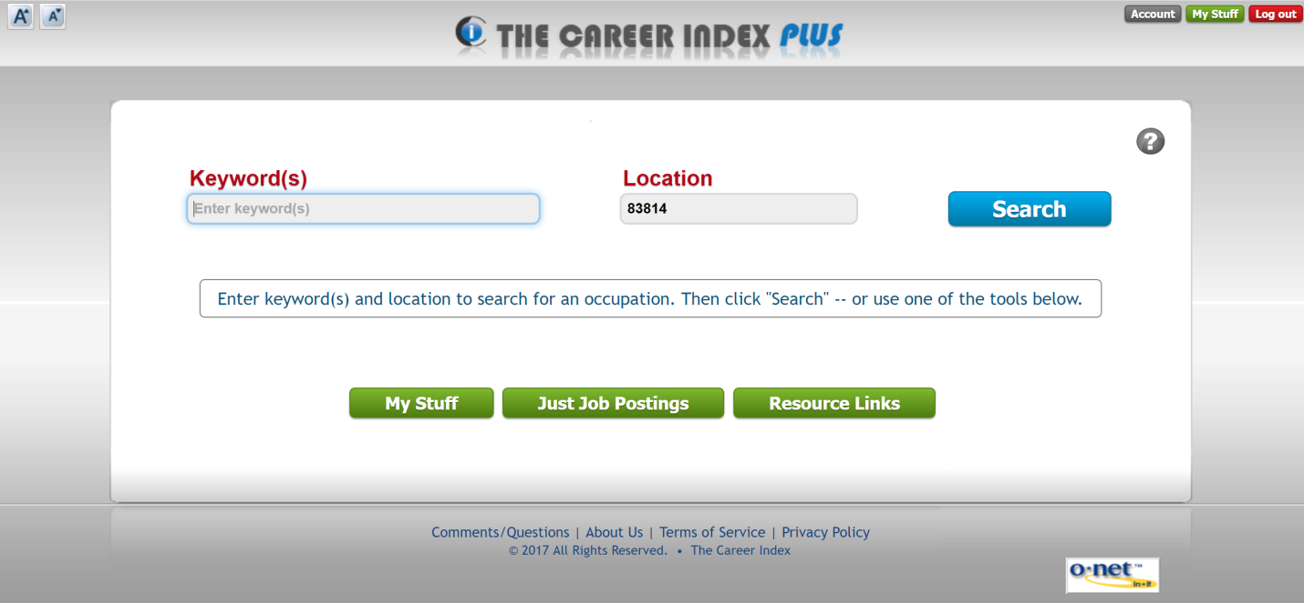
To return to the Home screen from any other screen within The Career Index Plus, click on the The Career Index Plus logo at the top of the screen, or the Home button.
There are two ways to get started using The Career Index Plus.
- To quickly find information about an occupation, including job openings, salaries, training, and more, conduct a Basic Search (see Quick Start Option 1: Conducting a Basic Search on page 2).
- To personalize The Career Index Plus to help you find and evaluate occupations depending on your needs and circumstances, start by creating a My Stuff profile (see Quick Start Option 2: Creating a My Stuff Profile on page 4).

Quick Start Option 1: Conducting a Basic Search
From the Home screen, enter a Keyword(s), enter a Location, and click Search. The results screen will display a list with the closest match listed first.
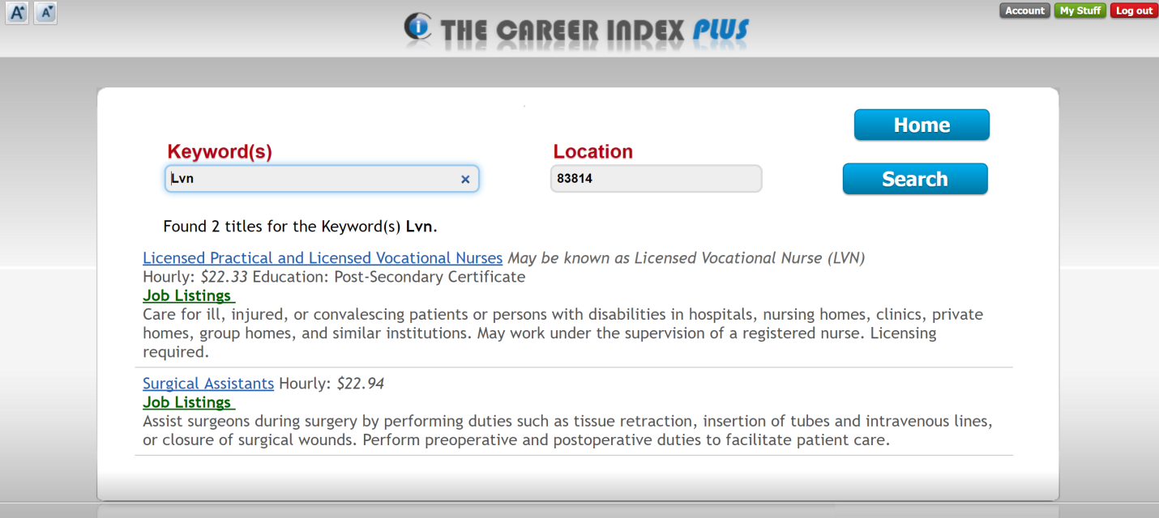
Clicking on a job title (blue) will provide detailed information about that job. Clicking on Job Listings (green) will provide a list of job openings in the specified location.
After clicking on a job title, the available information for the occupation is presented in tabs. Click on the tabs to access the information, or click the Print tab to download, email, or print the information in a report.
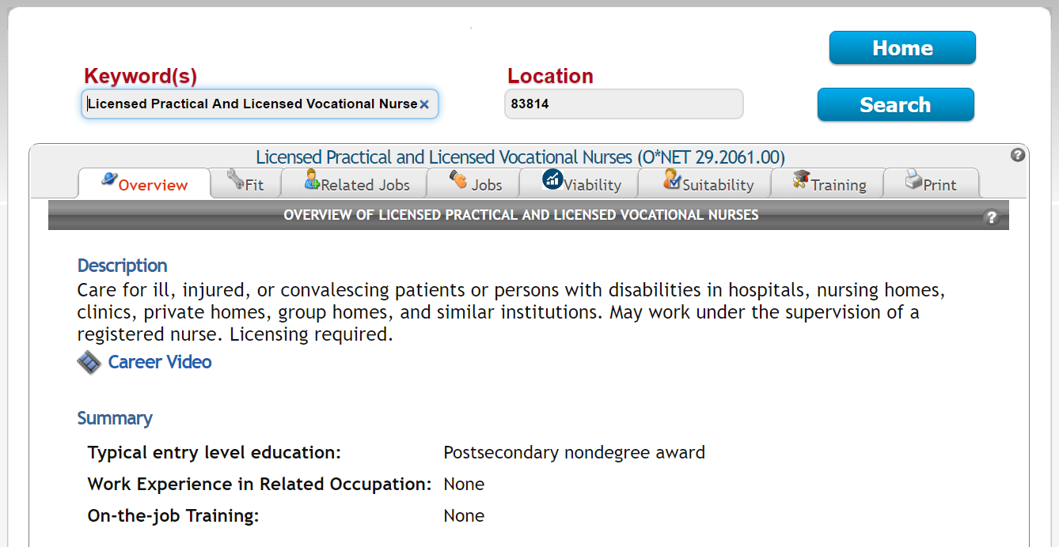

Quick Start Option 2: Creating a My Stuff Profile
From the Home screen, click on the My Stuff button (green), and create a password. Then click on the Profile tab, and complete each sub-tab from left to right, starting with Basics, and ending with Work Context. You can skip any sub-tabs that do not apply to you.
Once your My Stuff profile is complete, click on the Recommended tab to see a list of occupations based on your profile. Whenever you see a list of occupations in The Career Index Plus with a check-box next to it, checking the box saves the occupation to the Occupations tab. From there, you can compare occupations and print comparison reports.

Other Quick Start Options
From the Home screen, clicking on Just Job Postings allows you to search for positions that are currently posted on Indeed®.
From the Home screen, clicking on Resource Links provides additional resources for individuals with disabilities and ex-offenders.

