Quick Reference Card: Print Report

Printing, Emailing, or Saving a Report
With The Career Index Plus, counselors can easily customize a detailed occupational report for use with an Individual Employment Plan or Comprehensive Assessment. Clients can print or save reports to share with family members or friends.
When you click on the Print tab, you can select which information to include or exclude. Your selections will be saved, so next time you want to print, those options will be selected by default.
The Print selection includes three options:
- Print to screen. View all of the selected information areas on one screen, ideal for users with screen readers. It can also be used if you want to cut and paste report elements into a Word document.
- Email PDF Report. Enter an email address of a recipient (you, a family member, staff member, or friend). The PDF report is generated and sent to the specified email address.
- Download PDF report. Create a PDF and download it to your computer. Print the PDF or attach it to a case file.
Note: With the Check/Uncheck All box, you can check or uncheck all items in the report.
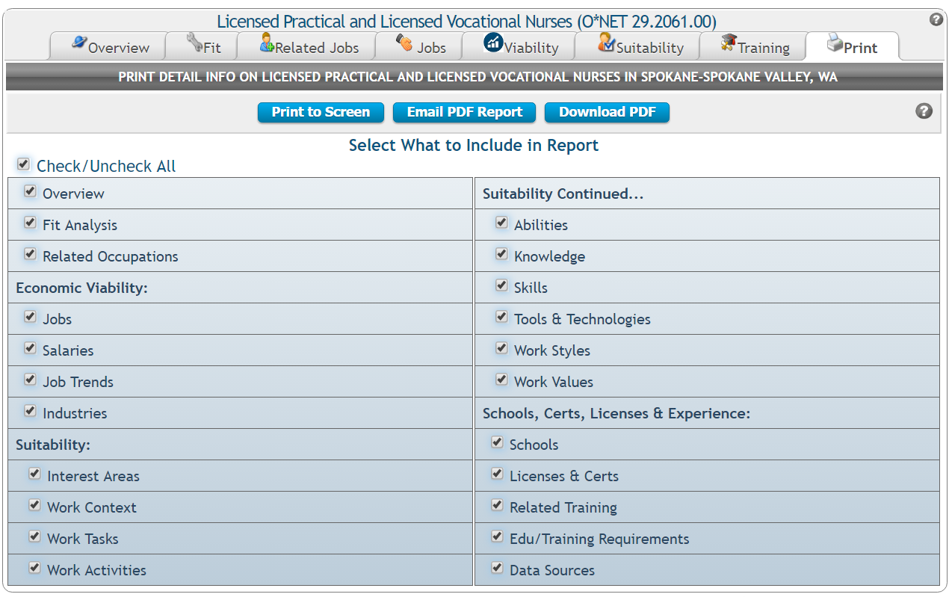

Viewing and Printing a Report
After selecting what to include in a report, the Print to Screen button opens the selected sections in a single screen (so you can scroll down, rather than using tabs, to view each section). The Print button at the top right corner of the report opens the browser’s print dialogue window. The Print to Screen button is also useful if you need to copy and paste information into another document.

Emailing a Report
After selecting what to include in a report, clicking the Email PDF Report button allows you to automatically email the report to another individual.
- Enter the name of the intended recipient (one only).
- Enter the email address of the intended recipient (one only).
- (Optional) Next to CC, enter your email address or the email address of another person (one only) to receive a copy of the email/report.
- (Optional) If desired, modify the Subject line.
- (Optional) Next to Add Email Text, enter a message to the recipient.
- Click Send Email.
The email will be sent as if from your email address, with the report as an Adobe PDF attachment. The screen will provide confirmation when the email/report has been sent.

Downloading and Opening a Report
After selecting what to include in a report, the Download PDF button downloads and opens the Adobe PDF report.
- The screen will say Document generation complete! when the download is complete.
- If the PDF file is not seen on screen, and no other on-screen instructions or dialogue boxes pop up, check the computer’s Downloads folder.
- Open the file using an Adobe PDF reader.
Once the file is open, you can view the report, copy and paste information from the report to another document or program, download the report, or print the report.

