Quick Reference Card: Job Title Overview

Overview
The Overview tab is designed to provide you with key information about the job title to determine if the occupation is viable and suitable.
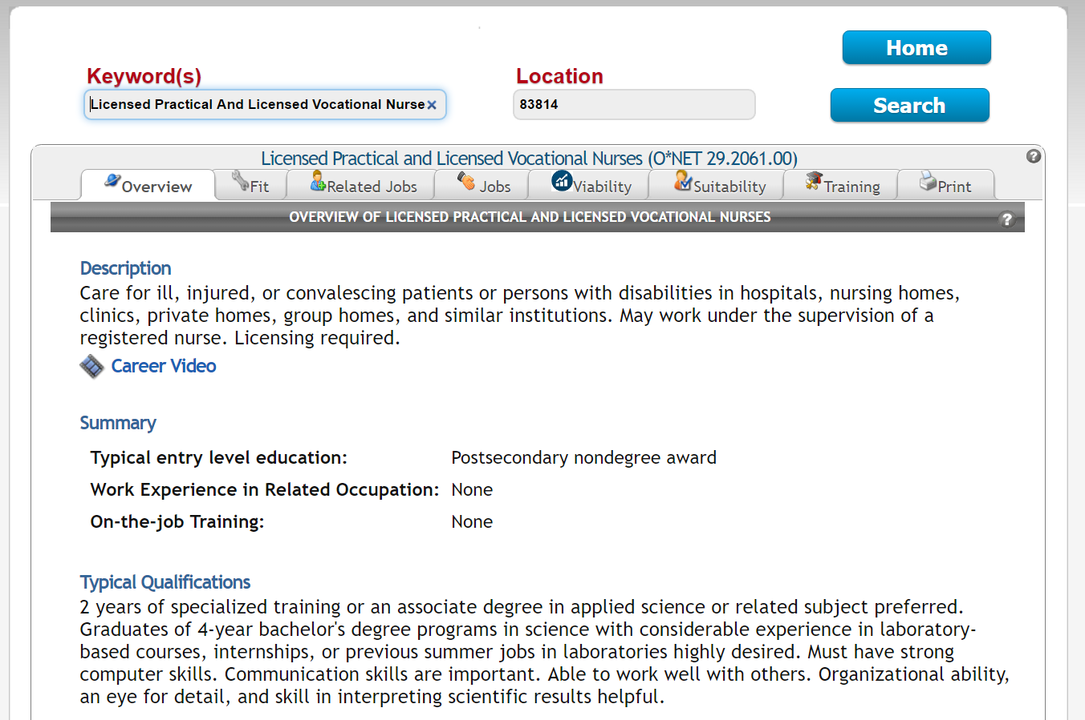
The Overview tab displays information from the Occupational Outlook Handbook provided by the U.S. Department of Labor’s Bureau of Labor Statistics. This includes the following:
- Title and job family
- Occupation description
- Work environment
- Work schedules
- National and state job outlook
- Number of local and state job postings (based on the specified location)
- Typical salary
- Entry-level education requirements
- Typical required experience
- How to become one (additional information about education and training)
- Important qualities/skills
At the bottom of the screen (not pictured), checking the box next to Save this occupation saves the occupation under My Stuff > Saved Occupations.

