Quick Reference Card: Job Postings
The Career Index Plus uses Indeed.com, the largest job search engine in the world, as its source of job postings.
Indeed.com is a “job posting aggregator,” which means it pulls job postings from state and federal job boards, all the major job posting sites, regional and niche sites, as well as corporate postings.
Indeed.com does not classify jobs by O*NET Code, so we have created advanced queries to help you retrieve relevant job openings. The queries are listed in the Keywords field and you are welcome to change them.
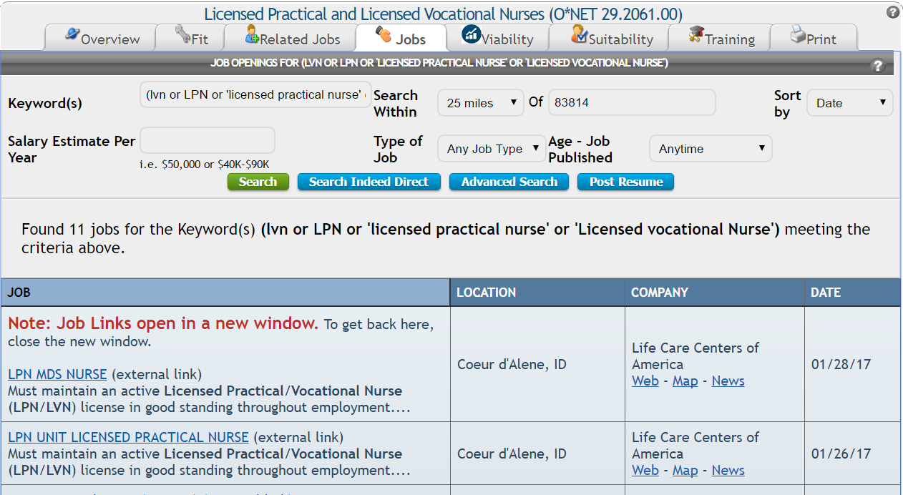

Job Postings Search
There are three ways to get to the job postings:
- When viewing job title details, click the Jobs tab.
- When viewing the search results, click the Job Listings link (green).
- From the Home Page, click the Just Job Postings button (green).
The main difference between these options is that when you click the Just Job Postings button, you will have to enter the search criteria yourself.
On the Search Screen, you can change a number of search parameters, including keywords, search radius, geographical area, type of job, when the job was posted, and salary range. When changing the search parameters, click the Search button (green) to see the results.

Optional Fields
Field Title | Description | Options | Default Setting
Search Within | Search radius | “Only in” the specified area, within 5, 10, 15, 25, 50, or 100 miles of the specified area, within the state, or nationally | Within 25 miles of the previously specified area
Salary Estimate Per Year | Desired annual salary or range | Any number or range may be entered (e.g., $50,000 or $40K-$90K), or the field may be left blank | Blank (all salaries)
Type of Job | Desired job type | Full-time, Part-time, Contract, Internship, or Temporary | Any/all job types
Age - Job Published | How long ago the job ad was posted by the employer | Anytime, Within the last 3, 7, or 15 days, Since yesterday, or Since the last visit | All job ads, regardless of when they were posted
Sort by | How you want the results to be displayed | Date (most to least recent), Job Title, Location, or Company | Most to least recent

Results
After clicking Search, the results will appear below the search area. If you are not seeing any jobs within the current Search Within setting, try changing it to the state or national level. If there are multiple pages of results, you can navigate through the pages using the page numbers below the search area and above the job listings.
Under the Jobs column, clicking a job title will open the job ad in a new window, where you can view, apply to, or email the ad. Under the Company column, clicking the Web link will open a Google search of the company. Clicking the Map link will open an interactive Google Map with the company’s name in the search field. When the Google Map opens, click the Google Search icon to map the company.

Searching Indeed® Directly
The Indeed® website contains additional filters, along with an option to receive email alerts when new jobs matching the search criteria are posted. To use these features, click on the Search Indeed Direct button below the search options. This opens a new window with the search results in Indeed®. A direct search in Indeed® may also help find highly specialized positions (e.g., “Board Certified Behavior Analyst”) that don’t fall neatly under a specific O*NET title.

Conducting an Advanced Search
For additional search options, or to further refine a search, click on the Advanced Search button. This opens the Indeed® Advanced Job Search page in a new window. An advanced search is particularly helpful when there are several search results that are not relevant to you.

Building and Posting a Resume
Once you’ve had a chance to review job ads, you can create (Build Your Resume) and post (Upload Resume) a resume through the Indeed® website. To use this feature, click on the Post Resume button below the search options.

