http://www.leadcenter.org/
http://www.leadcenter.org/about-us
The LEAD Center is a collaborative of disability, workforce and economic empowerment organizations dedicated to improving employment and economic advancement outcomes for all people with disabilities. The LEAD Center is funded by the Office of Disability Employment Policy, U.S. Department of Labohttp://www.oregon.gov/ODEr, Grant #OD-23863-12-75-4-11
Education Programs & Secondary Transition State-supported systems that provide direct services to Oregon's programs, districts and schools
Beginning not later than the first IEP to be in effect when the student is 16 and updated annually thereafter, the IEP must include the transition services (including courses of study) needed to assist the student in reaching the postsecondary goals. In situations in which the student is turning 16 during the duration of the IEP and updated annually thereafter, the IEP team may want to address these issues at the time of the annual review rather than meeting again before the student turns 16.
http://www.oregon.gov/ode/students-and-family/SpecialEducation/SecondaryTransition/Pages/Secondary-Transition-Services.aspx
Transition Reference Materials Flowchart

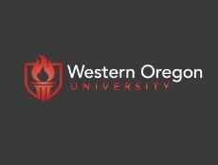

Teaching Research Institute
Western Oregon University
Resources related to transitioning youth with disabilities to adulthood in
Oregonhttp://triwou.org/projects/tcn
Transition Resource Handbook
http://triwou.org/projects/tcn/resourcebooklet

http://5c2cabd466efc6790a0a-6728e7c952118b70f16620a9fc754159.r37.cf1.rackcdn.com/cms/full_handbook_4785.pdf

TTAN
http://triwou.org/projects/tcn/ttanabout
This team is working to support the Governor’s Executive Order (No.15-01) to further improve Oregon’s systems of designing and delivering employment services for students with disabilities. Beginning July 2015, the Transition Technical Assistance Network includes ODE’s Secondary Transition Liaison, eight full-time Transition Network Facilitators, and one Regional Employment Coordinator and Trainer. The Transition Network Facilitator (TNF) will work to support the collaborative efforts of Vocational Rehabilitation and Local Education Agencies in Oregon in the implementation of the Workforce Innovate Opportunity Act and the provision of Pre-Employment Transition Services (Pre-ETS). The network is in its second year of development.

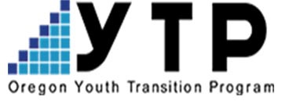The purpose of the YTP is to prepare students with disabilities for employment or career related postsecondary education or training through the provision of a comprehensive array of pre-employment transition services and supports.
TRI Teaching Research Institute Western Oregon University
YTP serves about 1500 students in approximately 120 Oregon high schools. VR contracts with the University of Oregon to provide training and technical assistance to school and rehabilitation personnel statewide to support implementation of YTP. Contracts with local school districts are performance based. YTP sites are expected to meet performance benchmarks based on key milestones within the VR system – application to VR, development of an individual plan for employment (IPE), and engagement in employment, training, or a combination of employment and training upon exiting the YTP pattern of service. A site’s performance on program benchmarks influences potential future funding. YTP staff collaborate with VR to create mechanisms to ensure the provision of pre-employment transition services (Pre-ETS), and provide core YTP Grant activities and supports in their districts. http://ytp.uoregon.edu/
Guided Group Discovery

http://www.leadcenter.org/resources/tool-manual/guided-group-discovery-resources-introduction-and-course-participant-workbook-and-facilitator-guide
| June 2017 | Tool/Manual
The Office of Disability Employment Policy (ODEP), at the U.S. Department of Labor (DOL), and the LEAD Center are pleased to release resources for Guided Group Discovery. Guided Group Discovery materials include a Facilitator Manual, an accompanying PowerPoint slide deck (Introduction and Course), and a Participant Workbook.
The purpose of Guided Group Discovery is to lay the foundation for competitive integrated employment as a Universal Design that can benefit all job seekers. For some people, Guided Group Discovery leads to Customized Employment. For everyone, the process assists job seekers in identifying employment that would be a good fit both for them and an employer
Motivational Interviewing
http://ytp.uoregon.edu/content/motivational-interviewing
An innovative approach has been developed by Anya Sheftel called MEGI which stands for Motivational Enhancement Group Intervention. MEGI is a Motivational Interviewing based group intervention for 14-21-year-old youth Motivational interviewing is grounded in respect, compassion, evocation, and acceptance.
A central concept of MI is the identification, examination, and resolution of ambivalence about change. Ambivalence, feeling two ways about something, is seen as a natural part of the change process.
The central concept of MI is the identification and examination of a student's own reasons for change. The skillful MI practitioner is attuned to the student's language of change.
Recent descriptions of Motivational Interviewing include three essential elements:
- MI is a particular kind of conversation about change (helping relationship, advising with permission, consultation, method of communication)
- MI is collaborative (person centered, partnership, honors autonomy, not expert recipient)
- MI is evocative (seeks to call forth the person’s own motivation and commitment)

By partnering with Worksystems, you can help local teens, especially from diverse and low-income communities, get their first work experience and an on-ramp to career success.
Here’s how it works:
Through SummerWorks we provide… • Work-readiness training prior to placement • Screening and matching youth based on the skills and preferences you specify in the position description • Ongoing job coaching to support the youth and the intern supervisor throughout the experience • Advising and networking opportunities to integrate the summer experience into each youth’s education and career goals • Employer-of-record services to include payroll processing, taxes, and insurance
Target Population:
Youth age 16-24 from across Multnomah and Washington counties can participate in SummerWorks. We work with school districts and community-based organizations to reach out to under- represented youth. The youth we work with are motivated and want to reconnect with school or work, but face many barriers such as growing up in poverty or lacking the necessary education.
SummerWorks Results: Since the program’s inception in 2009
• More than 85% of youth successfully completed their internship and received a positive evaluation from their supervisor • Over 90% of our employer partners would encourage their colleagues and business partners to participate • 93% of youth returned to high school, post-secondary, or became employed • The vast majority of youth were low-income and 75% were youth of color
http://summerworkspdx.org/

SummerWorks a program of WorkSystems
Are you between the ages of 16 – 24? Live in Multnomah or Washington County? SummerWorks may be right for you? SummerWorks is a public-private partnership that provides Portland Metro youth meaningful, paid summer work.
Why SummerWorks?
- GET PAID! 180 hours of work paid @ $12/hour
- Employers include Multnomah County, Washington County, City of Portland, City of Gresham, Providence Health Services, OHSU, and many different local businesses & non-profits
- Transportation assistance and other job-related supports available
- Most employers offer flexible work schedules
- A job coach will help you be successful in your summer job
For more information or to apply online visit: www.summerworkspdx.org
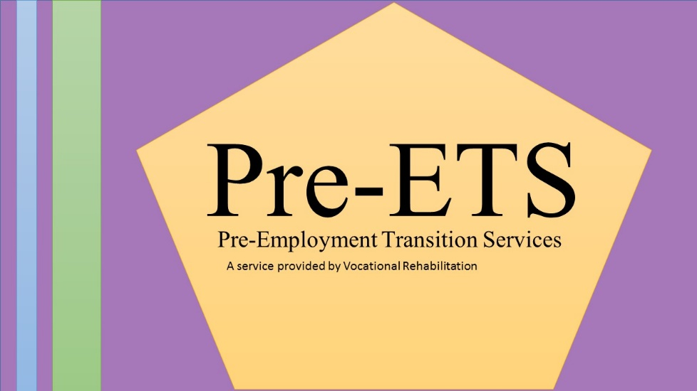

Pre-ETS (Pre-Employment Transition Services) The Workforce Innovation and Opportunity Act (WIOA) amends the Rehabilitation Act of 1973 and now requires vocational rehabilitation (VR) agencies to set aside at least 15% of their federal funds to provide "pre-employment transition services" to "Students with Disabilities who are eligible or potentially eligible for VR services."
Pre-Employment Transition Services (Pre-ETS) are program enhancement services as well as individualized student services that can be requested by individuals, educators or school districts. These services are customizable but must relate to one or more of the 5 Pre-ETS and serve an eligible population of students.
Pre-ETS activities are available for supporting and enhancing established or new programs in the state of Oregon upon request.

National Site for Pre-ETS
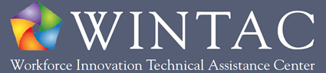

http://www.wintac.org/topic-areas/pre-employment-transition-services

